Tugas 3 Probabilitas & Statistika

Oleh
M Arief Kurniawan
09121001039
Bramantio Rizki Nugroho
NIM 09121001044
M Riduan Fabio
09121001066
Tahta Rizki Maulana
09121001070
Tomi Kiyatomoko
09011381520076

Jurusan Sistem Komputer
Fakultas Ilmu Komputer
Universitas Sriwijaya
2017
Practice 2.
3.10.3 Analisa Data
1. P(C) = $\frac{48}{100}$ = 0.48
2. P(L) =$\frac{37.6}{100}$ = 0.376
3. P (C|L) = $\frac{55}{100}$ = 0.55
4. “C|L” adalah diberikan untuk orang Latino California, merujuk pada pemilih (voter) yang telah teregistrasi tapi lebih memilih tinggal di dalam penjara tanpa pembebasan bersyarat serta terjerat kasus pembunuhan tingkat 1.
5. P(L AND C) = P(L) . P(C|L)
= 0.376 . 0.55
= 0.2068
6. “L AND C” adalah kejadian dimana yang terpilih/outcome dari pengambilan sample ialah Latino California, pemilih (voter) yang telah teregistrasi tapi lebih memilih tinggal di dalam penjara tanpa pembebasan bersyarat serta terjerat kasus pembunuhan tingkat 1
7. “L AND C” bukanlah kejadian independent, karena P(C) ≠ P(C|L)
8. P (L OR C) = P(L) + P(C) – P(L AND C)
= 0.48 + 0.376 – 0.2068
= 0.856 – 0.2068
= 0.6492
9. “L OR C” adalah peristiwa(events) dimana outcome yang terpilih adalah Latino California atau Seorang California yang telah teregistrasi tapi lebih memilih tinggal di dalam penjara tanpa pembebasan bersyarat serta terjerat kasus pembunuhan tingkat 1
10. “L and C” bukanlah mutually exclusive events karena P (L AND C) ≠ 0.

HOMEWORK
3.11.1
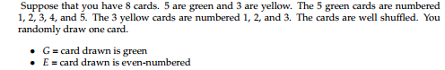
- Buatlah daftar sampelnya :
G = Green : G1, G2, G3, G4, G5
Y = Yellow : Y1, Y2, Y3
- Peluang (G) = 5/8
- Peluang (G | E) = 2/3
- Peluang (G AND E) = 2/8
- Peluang (G OR E) = 6/8
- Apakah G dan E merupakan data yg ekslusif? Tidak
3.11.2
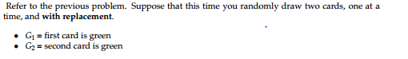
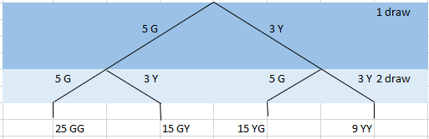
- Peluang (G1 AND G2) = (5/8) (5/8)
- Peluang (paling tidak satu hijau) = (5/8) (3/8) + (3/8) (5/8) + (5/8) (5/8)
- Peluang (G2 | G1) = (5/8)
- Apakah G2 dan G1 merupakan independen event? Tidak

3.11.3
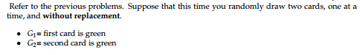
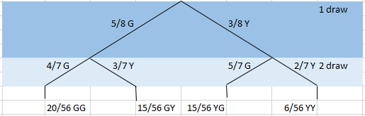
- Peluang (G1 AND G2) = (5/8) (4/7)
- Peluang (paling tidak satu hijau) = (5/8) (3/7) + (3/8) (5/7) + (5/8) (4/7)
- Peluang (G2 | G1) = 4/7
- Apakah G2 dan G1 merupakan independen event? Tidak
3.11.4
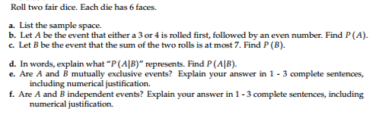
- Daftar sampel : {(genap, genap) , (genap, ganjil), (ganjil, genap), (ganjil, ganjil)}
- Apabila lemparan dadu pertama muncul angka 3 atau 4, dan lemparan dadu kedua muncul angka genap. Berapa peluangnya? 2/3
- Apabila keduan dadu di lempar bersamaan, berapa peluang muncul dadu berjumlah 7 atau lebih? 1/3
- P (A | B) adalah kemungkinan keluarnya peluang yang tidak berhubungan dengan keluarnya peluang yg lain.
P (A | B ) = 1
- Tidak, karena apabila terjadi peluang A, tetap tidak berpengaruh kepada peluang B
- Tidak, karena peluang A dan peluang B sama sama tidak berpengaruh
3.11.5
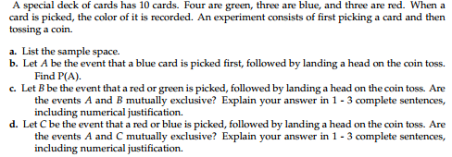
- {(hijau, kepala) , (hijau, ekor), (biru, kepala), (biru, ekor), (merah, kepala), (merah, ekor)}
- 3/20
- Ya, karena pada terjadinya peluang, kemungkinan selanjutnya dapat berepengaruh dengan saling meniadakan.
- Tidak,
3.11.6
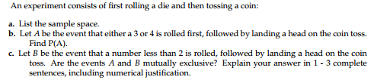
- {(genap, kepala) , (genap, ekor), (ganjil, kepala), (ganjil, ekor)
- 2/3
- Ya

3.11.7
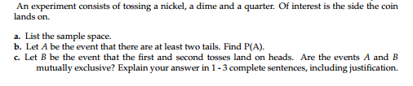
- {(kepala, kepala, kepala), (kepala, kepala, ekor), (kepala, ekor, kepala), (kepala, ekor, ekor), (ekor, kepala, kepala), (ekor, kepala, ekor), (ekor, ekor, kepala), (ekor, ekor,ekor)}
- 4/8
- Ya
3.11.8
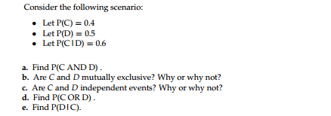
Exercise 3.11.8
P(C)=0.4; P(D)=0.5;P(C|D)=0.6
- P(C AND D) = 0.4*0.5
= 0.2
- No because P(C AND D)=0.2
- Yes because P(C AND D)=0.2
- P(C OR D) = 0.4+0.5-0.4*0.5
= 0.9-0.2
= 0.6
- P(D|C) = 0.5*0.4/0.4
= 0.5
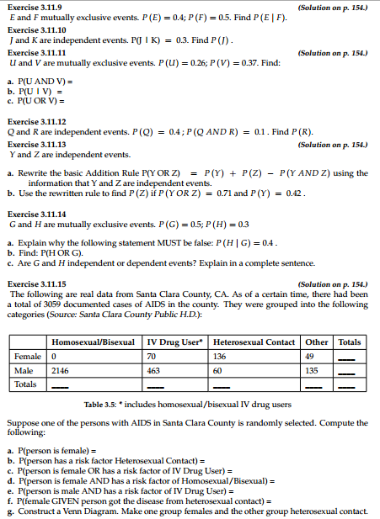
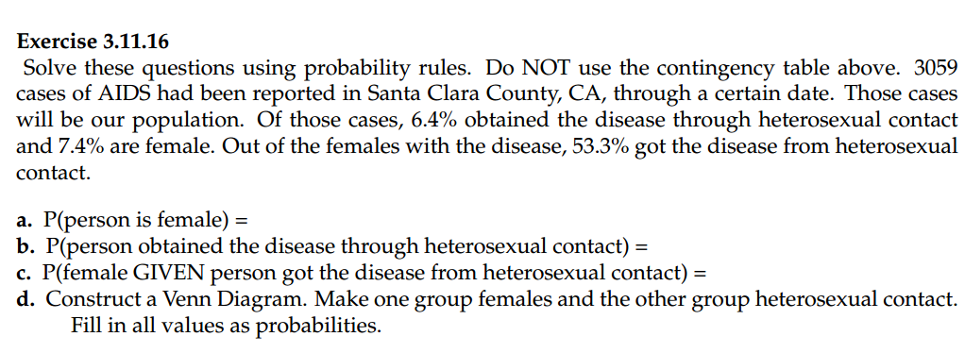
Answer Exercise 3.11.9 – 3.11.16
3.11.9
$$P\left(E | F\right)=\frac{P\left(E AND F\right)}{P\left(F\right)} \\ =\frac{P\left(E\right).P(F)}{P(F)}$$
$$=\frac{0.4*0.5}{0.5}$$
$$=\frac{0.2}{0.5}$$ $=0.4$
3.11.10
P(J|K) = 0.3
P(J)=0.3

3.11.11
- P(U AND V)=0, karena mutually exclusive event
- $P\left(U | V\right)=\frac{P\left(U\right).P(V)}{P(V)}$
$$=\frac{0.26*0.37}{0.37}$$
$$=0.26$$
- P(U OR V) = 0.26+0,37-0.26*0.37)
= 0.5338
3.11.12
P(Q)=0.4
P(Q AND R) = 0.1
0.4*P(R) = 0.1
P(R) = 0.1/0.4
= 0.25
3.11.14
P(G)=0.5 P(H)=0.3
- Why statement P(H|G)=0.4 FALSE ?
This is why :
$$P\left(H | G\right)=\frac{P\left(H\right).P\left(G\right)}{P\left(G\right)}$$
$$= \frac{0.3*0.5}{0.5}$$
$$=0.3$$
- P(H OR G) = P(H)+P(G)-P(H).P(G)
= 0.3+0.5-0.3*0.5
= 0.8-0.15
= 0,65
Exercise 3.11.15
 | Homosexual/Bisexual | IV Drug User* | Homosexual Contact | Other | Totals
Female | 0 | 70 | 136 | 49 | 255
Male | 2146 | 463 | 60 | 135 | 2804
Total | 2146 | 533 | 196 | 184 | 3059
- P(person is female) = 255/3059
- P(person has a risk factor Heterosexual Contact) = 196/3059
- P(person is female OR has a risk factor of IV Drug User) = 718/3059
- P(person is female AND has a risk factor of Homosexual/Bisexual) =0
- P(person is male AND has a risk factor of IV Drug User) =463/3059
- P(female GIVEN person got the disease from heterosexual contact) = 136/196
- Construct a Venn Diagram. Make one group females and the other group heterosexual contact.
Exercise 3.11.16
- P(person is female) = 0.074
- P(person obtained the disease through heterosexual contact) = 0.064
- P(female GIVEN person got the disease from heterosexual contact) =
Female in population : 0.074*3059=226.366
Female got the disease from heterosexual contact : 0.533*226.366=120.653078
P(female GIVEN person got the disease from heterosexual contact)=120.653078/226.366
- Construct a Venn Diagram. Make one group females and the other group heterosexual contact.
Fill in all values as probabilities.

3.11.17 (Solution on p. 155.)
The following table identifies a group of children by one of four hair colors, and by type of hair.
Hair Type | Brown | Blond | Black | Red | Totals
Wavy | 20 |  | 15 | 3 | 43
Straight | 80 | 15 |  | 12
Totals |  | 20 |  |  | 215
- Complete the table above.
Hair Type | Brown | Blond | Black | Red | Totals
Wavy | 20 | 5 | 15 | 3 | 43
Straight | 80 | 15 | 65 | 12 | 172
Totals | 100 | 20 | 80 | 15 | 215

b. What is the probability that a randomly selected child will have wavy hair?
Jawab: P(Wavetotals)/ntotals = 43/215
c. What is the probability that a randomly selected child will have either brown or blond hair?
Jawab: P(BrownTotals+P(BlondTotals)/ntotals = 120/215
d. What is the probability that a randomly selected child will have wavy brown hair?
Jawab: P(WavyBrown)/ntotals= 20/215
e. What is the probability that a randomly selected child will have red hair, given that he has
straight hair?
Jawab: P(RedStraight)/nTotalsStraight=12/172
f. If B is the event of a child having brown hair, find the probability of the complement of B.
Jawab:P(Brownhair)+P(Brownhair)`=1
100/215 + P(Brownhair)`= 1
P(Brownhair)`= 1-100/215
= 115/215
g. In words, what does the complement of B represent?
Jawab:BlackBrown

3.11.18
A previous year, the weights of the members of the San Francisco 49ers and the Dallas Cowboys
were published in the San Jose Mercury News. The factual data are compiled into the following
table.

Shirt# | <210 | 211-250 | 251-290 | 290> | totals
1-33 | 21 | 5 | 0 | 0 | 26
34-66 | 6 | 18 | 7 | 4 | 35
66-99 | 6 | 12 | 22 | 5 | 45
totals | 33 | 35 | 29 | 9 | 106

Table 3.7
For the following, suppose that you randomly select one player from the 49ers or Cowboys.
- Find the probability that his shirt number is from 1 to 33.
Jawab: P(1-33totals)/n(totals)=26/106
- Find the probability that he weighs at most 210 pounds.
Jawab:P(<210 totals)/n(totals)= 33/106
- Find the probability that his shirt number is from 1 to 33 AND he weighs at most 210 pounds.
Jawab: P(1 to 33 AND he weighs at most 210 pounds)= 21/106
- Find the probability that his shirt number is from 1 to 33 OR he weighs at most 210 pounds.
Jawab: P(1 to 33 OR he weighs at most 210 pounds)= (26/106)+(33/106)-21/106=80/106
- Find the probability that his shirt number is from 1 to 33 GIVEN that he weighs at most 210
pounds.
Jawab: P(1 to 33 GIVEN that he weighs at most 210 pounds)=21/33
- If having a shirt number from 1 to 33 and weighing at most 210 pounds were independent events, then what should be true about P(Shirt# 1-33 | _ 210 pounds)?
Jawab : P (AIB) = P (A)
P (Shirt# 1-33 | _ 210 pounds)
= P(Shirt 1-33 and 210pounds)/210pounds
=21/106
3.11.19 (Solution on p. 155.)
Approximately 281,000,000 people over age 5 live in the United States. Of
these people, 55,000,000 speak a language other than English at home. Of
those who speak another language at home, 62.3% speak Spanish. (Source:
http://www.census.gov/hhes/socdemo/language/data/acs/ACS-12.pdf)
Let: E = speak English at home; E’ = speak another language at home; S = speak Spanish;
Finish each probability statement by matching the correct answer.
Sekitar 281.000.000 orang di atas usia 5 live di Amerika Serikat. Dari orang-orang ini, 55.000.000 berbicara bahasa lain selain bahasa Inggris di rumah. Dari orang-orang yang berbicara bahasa lain di rumah, 62,3% berbicara bahasa Spanyol. (Sumber: http://www.census.gov/hhes/socdemo/language/data/acs/ACS-12.pdf) Mari: E = berbahasa Inggris di rumah; = E 'berbicara bahasa lain di rumah; S = berbicara bahasa Spanyol;
E’=55.000.000 S+E+E’=281000000
S=62,3% 62,3/100*281.000.000=175.060.000 175.063.000+E+55.000.000=281000000
230.063.000+E=281000000
E=281.000.000-230.063.000
E=50.937.000
Probability Statements | Answers
a. P(E’) = iii |  | i. 0.8043
b. P(E) = i |  | ii. 0.623
c. P(S and E’) = iv |  | iii. 0.1957
d. P(S|E’) = ii |  | iv. 0.1219
Table 3.8

3.11.20
The probability that a male develops some form of cancer in his lifetime is 0.4567 (Source: American
Cancer Society). The probability that a male has at least one false positive test result (meaning
the test comes back for cancer when the man does not have it) is 0.51 (Source: USA Today). Some of the questions below do not have enough information for you to answer them. Write “not enough
information” for those answers.
Let: C = a man develops cancer in his lifetime; P = man has at least one false positive
Peluang laki-laki mengembangkan beberapa bentuk kanker dalam hidupnya adalah 0,4567 (Sumber: Amerika Cancer Society). Peluang laki-laki memiliki setidaknya satu hasil tes positif palsu (yang berarti tes datang kembali untuk kanker ketika seorang pria tidak memilikinya) adalah 0,51 (Sumber: USA Today). Beberapa pertanyaan di bawah ini tidak memiliki informasi yang cukup bagi Anda untuk menjawab mereka. Menulis "tidak cukuup Informasi "untuk jawaban mereka. Mari: C = seorang pria mengembangkan kanker dalam hidupnya; P = manusia memiliki setidaknya satu positif palsu
a. Construct a tree diagram of the situation.
b. P (C) = 0,51
c. P(PIC) =P(PIC)/P(C) = 0.033
d. P(PIC’ ) =
P(PIC`)/P(C`)=0,51*0,49/0,49 P(P)+P(C’)=1
=0,51 0,51+P(C’)=1
P(C’)=1-0,51
P(C’)=0,49
e. If a test comes up positive, based upon numerical values, can you assume that man has cancer?
Justify numerically and explain why or why not.

3.11.21 (Solution on p. 155.)
In 1994, the U.S. government held a lottery to issue 55,000 Green Cards (permits for non-citizens
to work legally in the U.S.). Renate Deutsch, from Germany, was one of approximately 6.5 million
people who entered this lottery. Let G = won Green Card.
- What was Renate’s chance of winning a Green Card? Write your answer as a probability
statement.
Jawab: P (G) = 0.008
- In the summer of 1994, Renate received a letter stating she was one of 110,000 finalists chosen.Once the finalists were chosen, assuming that each finalist had an equal chance to win, what was Renate’s chance of winning a Green Card? Let F = was a finalist. Write your answer as a conditional probability statement.
Jawab: 0,5
- Are G and F independent or dependent events? Justify your answer numerically and also
explain why.
Jawab: Dependent
- Are G and F mutually exclusive events? Justify your answer numerically and also explain why.NOTE: P.S. Amazingly, on 2/1/95, Renate learned that she would receive her Green Card – true story!
Jawab: No.
3.11.22
Three professors at George Washington University did an experiment to determine if economists
are more selfish than other people. They dropped 64 stamped, addressed envelopes with $10 cash
in different classrooms on the George Washington campus. 44% were returned overall. From the
economics classes 56% of the envelopes were returned. From the business, psychology, and history
classes 31% were returned. (Source: Wall Street Journal )
Let: R = money returned; E = economics classes; O = other classes
- Write a probability statement for the overall percent of money returned.
Jawab: P(R) = 44% atau 0,44
- Write a probability statement for the percent of money returned out of the economics classes.
Jawab: 56% E,
31% O,
44% secara keseluruhan
Secara keseluruhan = (56 - 31) / 44 = 56,82% dari E sampai O.
56,82% dari peserta E dan 43,18% adalah O.
Ini berarti ada 64 * 0,5682 = 36,3648
Uang kembali 36,3648 profesor E = 36,3648 * 56% = 20,364 (dibulatkan) Jadi 20 uang pengembalian
Jadi , 20 * $ 10 = $ 200
- Write a probability statement for the percent of money returned out of the other classes.
Jawab: 56% E,
31% O,
44% secara keseluruhan
Secara keseluruhan = (56 - 31) / 44 = 56,82% dari E sampai O.
56,82% dari peserta E dan
E+O=100%
56,82%+O=100%
O=100%-56,82%=43,18%
43,18% adalah O.
Ini berarti ada 64 * 0,4318 = 27,6352
Uang kembali 27,6352= 27,6352* 31% = 8.566 Jadi 8.5 uang pengembalian
Jadi , 8.5* $ 10 = $ 85

- Is money being returned independent of the class? Justify your answer numerically and explain it.
- Based upon this study, do you think that economists are more selfish than other people? Explain why or why not. Include numbers to justify your answer.

3.11.23 (Solution on p. 155.)
The chart below gives the number of suicides estimated in the U.S. for a recent year by age, race
(black and white), and sex. We are interested in possible relationships between age, race, and sex.
We will let suicide victims be our population. (Source: The National Center for Health Statistics,
U.S. Dept. of Health and Human Services)

Race and Sex | 1 - 14 | 15 - 24 | 25 - 64 | over 64 | TOTALS
white, male | 210 | 3360 | 13610 |  | 22050
white, female | 80 | 580 | 3380 |  | 4930
black, male | 10 | 460 | 1060 |  | 1670
black, female | 0 | 40 | 270 |  | 330
all others

TOTALS | 310 | 4650 | 18780 |  | 29760

Table 3.9
NOTE: Do not include "all others" for parts (f), (g), and (i).
- Fill in the column for the suicides for individuals over age 64.
Race and Sex | 1 - 14 | 15 - 24 | 25 - 64 | over 64 | TOTALS
white, male | 210 | 3360 | 13610 | 4870 | 22050
white, female | 80 | 580 | 3380 | 890 | 4930
black, male | 10 | 460 | 1060 | 140 | 1670
black, female | 0 | 40 | 270 | 20 | 330
all others |  |  |  | 100
TOTALS | 310 | 4650 | 18780 | 6020 | 29760

- Fill in the row for all other races.
Race and Sex | 1 - 14 | 15 - 24 | 25 - 64 | over 64 | TOTALS
white, male | 210 | 3360 | 13610 | 4870 | 22050
white, female | 80 | 580 | 3380 | 890 | 4930
black, male | 10 | 460 | 1060 | 140 | 1670
black, female | 0 | 40 | 270 | 20 | 330
all others | 10 | 210 | 460 | 100 | 780
TOTALS | 310 | 4650 | 18780 | 6020 | 29760

- Find the probability that a randomly selected individual was a white male.
Jawab: P(white male) = 22050/29760
- Find the probability that a randomly selected individual was a black female.
Jawab: P(black female)= 330/29760
- Find the probability that a randomly selected individual was black
Jawab: P(black) = 2000/29760
- Find the probability that a randomly selected individual was male.
Jawab: P(male)=23720/29760
- Out of the individuals over age 64, find the probability that a randomly selected individual was
a black or white male.
Jawab: P(a black or white male)= 5010/6020
- Comparing “Race and Sex” to “Age,” which two groups are mutually exclusive? How do you
know?
Black females and ages 1-14
- Are being male and committing suicide over age 64 independent events? How do you know?
No. P(male) = 22050; P(maleIover agee64) = 17180. So does not equal

The next two questions refer to the following: The percent of licensed U.S. drivers (from a recent year) that are female is 48.60. Of the females, 5.03% are age 19 and under; 81.36% are age 20 - 64; 13.61% are age 65 or over. Of the licensed U.S. male drivers, 5.04% are age 19 and under; 81.43% are age 20 - 64; 13.53% are age 65 or over. (Source: Federal Highway Administration, U.S. Dept. of Transportation)
3.11.24
Complete the following:
- Construct a table or a tree diagram of the situation.
 | 19 and under | 20-64 | age 65 or over | Total
Female | 2,44 | 39.54 | 6.62 | 48,60
Male | 2.59 | 41.86 | 6.95 | 51,40
Total | 5,03 | 81,4 | 13,57 | 100
b. P(driver is female) =48,60/100
c. P(driver is age 65 or over | driver is female) =(6,62/100)/(48,60/100)=0,06/0,48
d. P(driver is age 65 or over AND female) =6,62/100
e. In words, explain the difference between the probabilities in part (c) and part (d).
f. P(driver is age 65 or over) =13,57/100
3.11.25
Misalkan 10.000 supir berlisensi dipilih secara acak
- Yang dipilih adalah laki-laki
P(laki-laki) = $\frac{51.4}{100}$ x10000= 5140

 | < 20 tahun | 20 – 64 tahun | > 64 tahun | Total
Female | 0.0244 | 0.3954 | 0.0661 | 0.486
Male | 0.0259 | 0.4186 | 0.0695 | 0.514
Total | 0.0503 | 0.8140 | 0.1356 | 1

- 0.3954

3.11.26
 | Berkendara (Mobil, Truk, Van) | Jalan Kaki | Transportasi Umum | Lain-lain | Total
Pergi Sendirian | 0.7318
Pergi bersama-sama (Carpool) | 0.1332
Total | 0.865 | 0.039 | 0.053 | 0.043 | 1

b. Dengan Asumsi pejalan kaki pergi sendirian
P(Pergi Sendirian) = 0.7318 + 0.039 = 0.7708
c. 0.7708 x 1000 = 771 orang

d. 0.1332 x 1000 = 133 orang

3.11.27
a. If there’s a 60% chance of rain on Saturday and a 70% chance of rain on Sunday, then there’s a 130% chance of rain over the weekend.
Jawaban :
Pada kalimat diatas kesalahannya adalah probabilitas tidak pernah lebih besar daripada 100%
b. The probability that a baseball player hits a home run is greater than the probability that he
gets a successful hit.
Jawaban :
Kesalahan pada kalimat diatas ialah homerun dikategorikan sebagai pukulan (hit) sukses. Sehingga setidak-tidaknya pemain memiliki probabilitas pukulan (hit) yang sukses sama besar dengan probabilitas homerun.

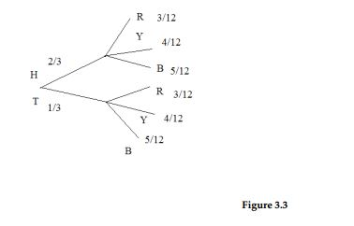

3.11.28
P(H AND R) = P(H) . P(R|A)
= 2/3 . 3/12
= 6/36
C. $\frac{6}{36}$

3.11.29
P(B) = 5/12 = 15/36
- $\frac{15}{36}$
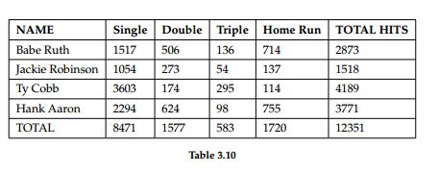
3.11.30
P(hit was made by Babe Ruth) = $\frac{2873}{12351}$
- $\frac{2873}{12351}$
3.11.31
P(hit was made by Ty Cobb | The hit was a Home Run) = $\frac{114}{1720}$

- $\frac{114}{1720}$
3.11.32
Apakah pukulan yang dibuat oleh Hank Aaron and pukulan double adalah kejadian independen (independent event)?
- No, because P(hit is by Hank Aaron | hit is a double) ≠ P(hit by Hank Aaron)

Jawaban

3.11.33.
P(G) = 0,43 ; P(H) = 0,26 ; P(H and G) = 0,14
P(H or G) = P(H) + P(G) – P(H and G)
= 0,26 + 0,43 – 0,14
= 0,55
b. P(H’ and G’) = 1 - 0,14 = 0,86
c. P(H’ or G’) = 1 – 0,55 = 0,45
3.11.34.
P(J) = 0,18 ; P(K)= 0,37 ; P(J or K)= 0,45
a. P(J and K) = P(J) + P(K)
= 0,18 . 0,37
= 0,06
b. P(J’ and K’) = 1 - 0,06 = 0,94
c. P(J’ or K’) = 1 – 0,45 = 0,55

3.11.35.
if type O = A = 45% = 0.43 ; Rh- = B = 15% = 0.15
a. P(A or B) = 0,43 + 0,15
= 0,58
b. P(A’ and B’) = 1 – 0,58 = 0,42
= 42%

3.11.36.
a. P(R or F) = P(R) + P(F)
= 0,72 + 0,46
= 1,18
b. 1- P(R or F) = 1 – 1,18
= -0,18

3.11.37.
a. P(C or N ) = P(C) + P(N) – P(C and N)
= 0,36 + 0,12 – 0,08
= 0,4
b. 1 – P(C or N) = 1 – 0,4
= 0,6
3.11.38.
a. P(D and E) = 0,2 . 0,4 = 0,08
b. P(E|D) = P(D and E) / P(D) = 0.08 / 0.1 = 0,42
c. P(D or E) = P(D) + P(E) – P(D and E)
= 0.1 + 0.4 – 0,08
= 0,42
d. Tidak independent karena P(D and E) tidak sama dengan P(D)
e. Tidak mutually exclusive karena nilai P(D and E) tidak sama dengan 0

3.11.39.
a. P(H) = 140/250 = 0,56
P(T) = 110/250 = 0,44
bcd.
110T
140H

280HH 250HT 250TH 220TT
140H
110T
110T
140H

3.11.40.
n/10 dimakan pertama
n/s dimakan ke 2

1A
7B
7B
1A
1A
7B

