**LAPORAN KEAMANAN JARINGAN KOMPUTER**



Oleh:

Alvin Mulya Pradana

09040581721015

Teknik Komputer Jaringan

**LABORATORIUM TKJ**

**FAKULTAS ILMU KOMPUTER**

[www.kompas.com](http://www.kompas.com)

1. Analisis menggunakan Netcraft

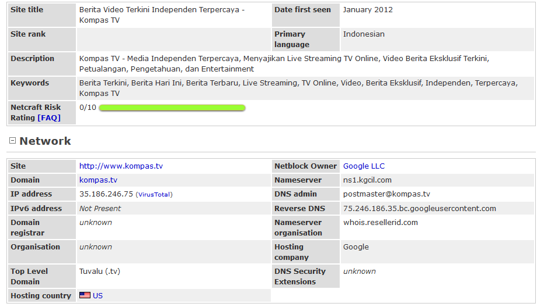

1. Analisis menggunakan whois

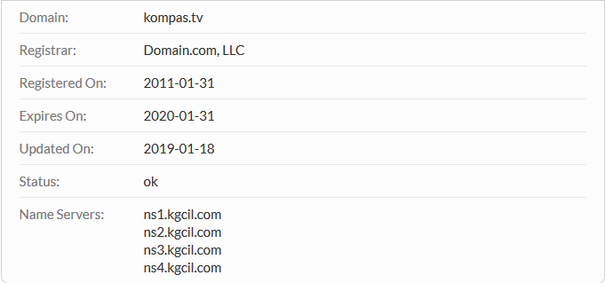

**Raw Whois Data**

Domain Name: KOMPAS.TV

Registry Domain ID:

Registrar WHOIS Server: whois.domain.com

Registrar URL: www.domain.com

Updated Date: 2019-01-18T11:13:31

Creation Date: 2011-01-31T06:55:24

Registrar Registration Expiration Date: 2020-01-31T06:55:24

Registrar: Domain.com, LLC

Registrar IANA ID: 886

Reseller: Domain.com

Domain Status: ok

Registry Registrant ID:

Registrant Name: REDACTED FOR PRIVACY

Registrant Organization: REDACTED FOR PRIVACY

Registrant Street: REDACTED FOR PRIVACY

Registrant City: REDACTED FOR PRIVACY

Registrant State/Province: REDACTED FOR PRIVACY

Registrant Postal Code: REDACTED FOR PRIVACY

Registrant Country: REDACTED FOR PRIVACY

Registrant Phone: REDACTED FOR PRIVACY

Registrant Phone Ext:

Registrant Fax: REDACTED FOR PRIVACY

Registrant Fax Ext:

Registrant Email: REDACTED FOR PRIVACY

Registry Admin ID:

Admin Name: REDACTED FOR PRIVACY

Admin Organization: REDACTED FOR PRIVACY

Admin Street: REDACTED FOR PRIVACY

Admin City: REDACTED FOR PRIVACY

Admin State/Province: REDACTED FOR PRIVACY

Admin Postal Code: REDACTED FOR PRIVACY

Admin Country: REDACTED FOR PRIVACY

Admin Phone: REDACTED FOR PRIVACY

Admin Phone Ext:

Admin Fax: REDACTED FOR PRIVACY

Admin Fax Ext:

Admin Email: REDACTED FOR PRIVACY

Registry Tech ID:

Tech Name: REDACTED FOR PRIVACY

Tech Organization: REDACTED FOR PRIVACY

Tech Street: REDACTED FOR PRIVACY

Tech City: REDACTED FOR PRIVACY

Tech State/Province: REDACTED FOR PRIVACY

Tech Postal Code: REDACTED FOR PRIVACY

Tech Country: REDACTED FOR PRIVACY

Tech Phone: REDACTED FOR PRIVACY

Tech Phone Ext:

Tech Fax: REDACTED FOR PRIVACY

Tech Fax Ext:

Tech Email: REDACTED FOR PRIVACY

Name Server: ns1.kgcil.com

Name Server: ns3.kgcil.com

Name Server: ns4.kgcil.com

Name Server: ns2.kgcil.com

Registrar Abuse Contact Email: email@domain-inc.net

Registrar Abuse Contact Phone: +1.6027165396

>>> Last update of WHOIS database: 2019-01-18T11:13:31 <<<

Registration Service Provider:

Domain.com, email@domain-inc.net

+1.8004033568

This company may be contacted for domain login/passwords,

DNS/Nameserver changes, and general domain support questions.

1. Analisis menggunakan Web Archive

Update pada tahun 2018

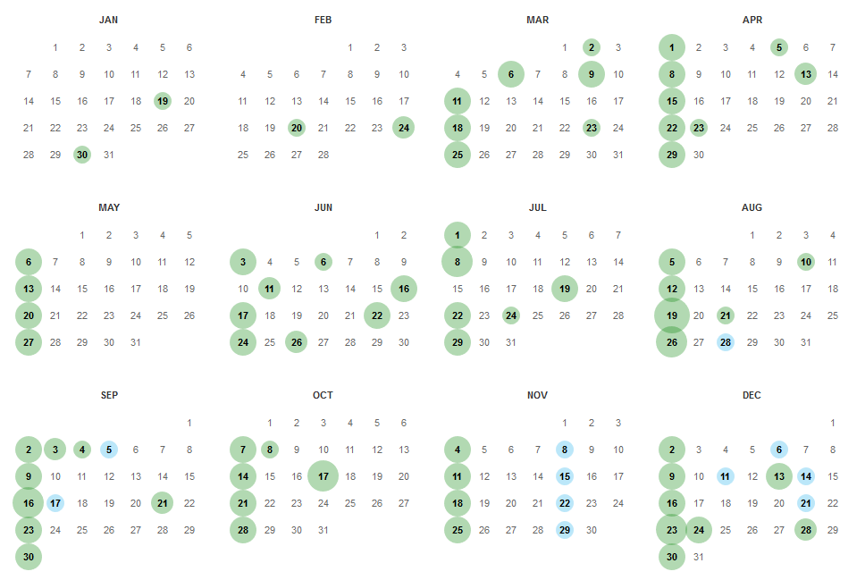

1. Analisis menggunakan Robtex

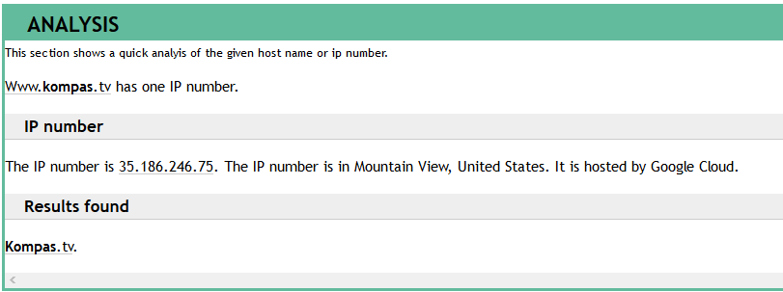

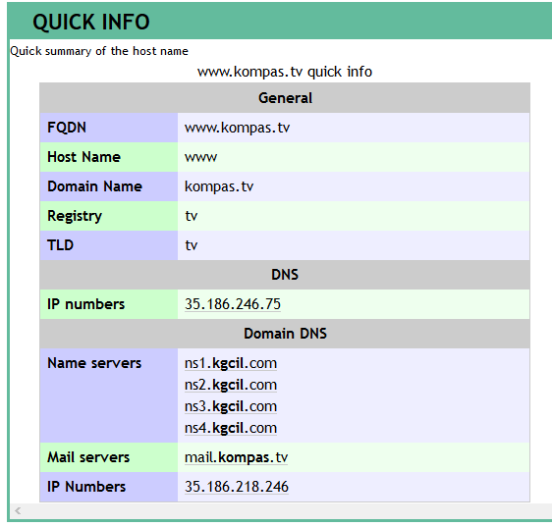

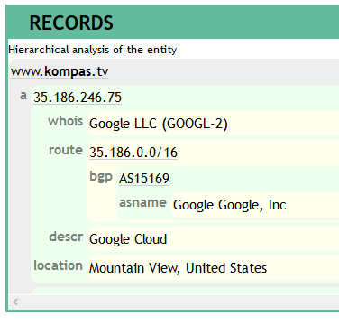

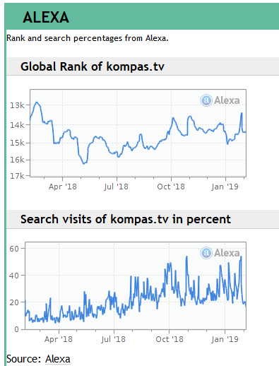

1. Analisis menggunakan Wireshak

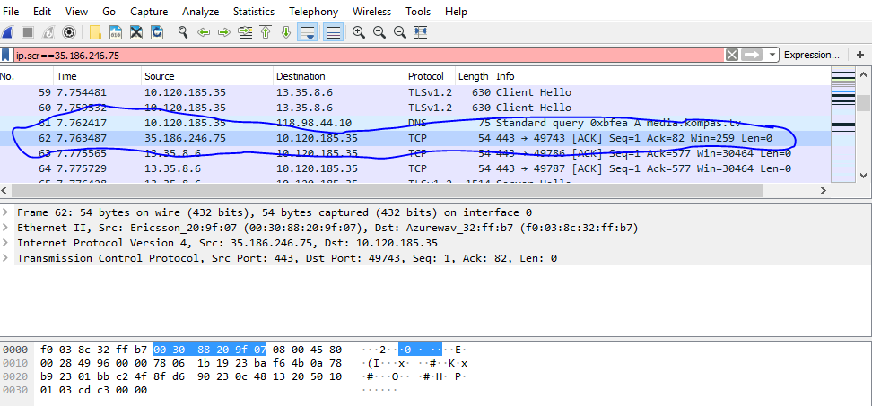

[www.sindonews.com](http://www.sindonews.com)

1. Analisis menggunakan Netcraft

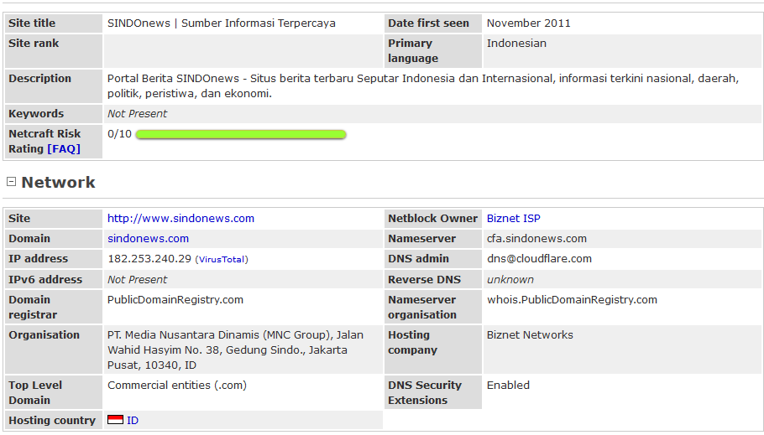

1. Analisis menggunakan Whois

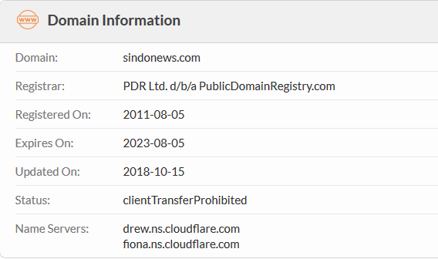

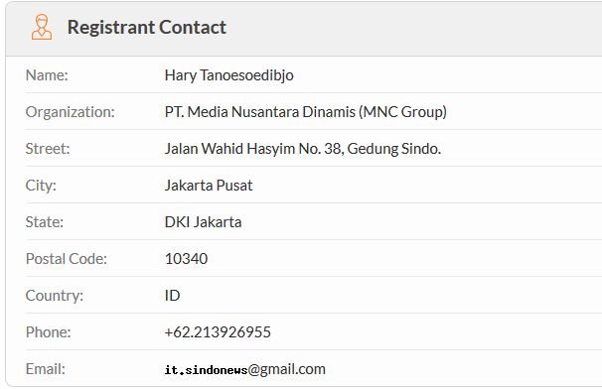

**Raw Whois Data**

Domain Name: SINDONEWS.COM

Registry Domain ID: 1670504789_DOMAIN_COM-VRSN

Registrar WHOIS Server: whois.publicdomainregistry.com

Registrar URL: www.publicdomainregistry.com

Updated Date: 2019-01-01T01:06:20Z

Creation Date: 2011-08-05T03:00:59Z

Registrar Registration Expiration Date: 2023-08-05T03:00:59Z

Registrar: PDR Ltd. d/b/a PublicDomainRegistry.com

Registrar IANA ID: 303

Domain Status: clientTransferProhibited https://icann.org/epp#clientTransferProhibited

Registry Registrant ID: Not Available From Registry

Registrant Name: Hary Tanoesoedibjo

Registrant Organization: PT. Media Nusantara Dinamis (MNC Group)

Registrant Street: Jalan Wahid Hasyim No. 38, Gedung Sindo.

Registrant City: Jakarta Pusat

Registrant State/Province: DKI Jakarta

Registrant Postal Code: 10340

Registrant Country: ID

Registrant Phone: +62.213926955

Registrant Phone Ext:

Registrant Fax:

Registrant Fax Ext:

Registrant Email: @gmail.com

Registry Admin ID: Not Available From Registry

Admin Name: Hary Tanoesoedibjo

Admin Organization: PT. Media Nusantara Dinamis (MNC Group)

Admin Street: Jalan Wahid Hasyim No. 38, Gedung Sindo.

Admin City: Jakarta Pusat

Admin State/Province: DKI Jakarta

Admin Postal Code: 10340

Admin Country: ID

Admin Phone: +62.213926955

Admin Phone Ext:

Admin Fax:

Admin Fax Ext:

Admin Email: @gmail.com

Registry Tech ID: Not Available From Registry

Tech Name: Hary Tanoesoedibjo

Tech Organization: PT. Media Nusantara Dinamis (MNC Group)

Tech Street: Jalan Wahid Hasyim No. 38, Gedung Sindo.

Tech City: Jakarta Pusat

Tech State/Province: DKI Jakarta

Tech Postal Code: 10340

Tech Country: ID

Tech Phone: +62.213926955

Tech Phone Ext:

Tech Fax:

Tech Fax Ext:

Tech Email: @gmail.com

Name Server: drew.ns.cloudflare.com

Name Server: fiona.ns.cloudflare.com

DNSSEC: Unsigned

Registrar Abuse Contact Email: @publicdomainregistry.com

Registrar Abuse Contact Phone: +1.2013775952

URL of the ICANN WHOIS Data Problem Reporting System: http://wdprs.internic.net/

>>> Last update of WHOIS database: 2019-02-04T14:26:45Z <<<

For more information on Whois status codes, please visit https://icann.org/epp

Registration Service Provided By: MWN

The data in this whois database is provided to you for information purposes

only, that is, to assist you in obtaining information about or related to a

domain name registration record. We make this information available "as is",

and do not guarantee its accuracy. By submitting a whois query, you agree

that you will use this data only for lawful purposes and that, under no

circumstances will you use this data to:

(1) enable high volume, automated, electronic processes that stress or load

this whois database system providing you this information; or

(2) allow, enable, or otherwise support the transmission of mass unsolicited,

commercial advertising or solicitations via direct mail, electronic mail, or

by telephone.

The compilation, repackaging, dissemination or other use of this data is

expressly prohibited without prior written consent from us. The Registrar of

record is PDR Ltd. d/b/a PublicDomainRegistry.com.

We reserve the right to modify these terms at any time.

By submitting this query, you agree to abide by these terms.

1. Analisis menggunakan Web Archive

Update pada tahun 2018

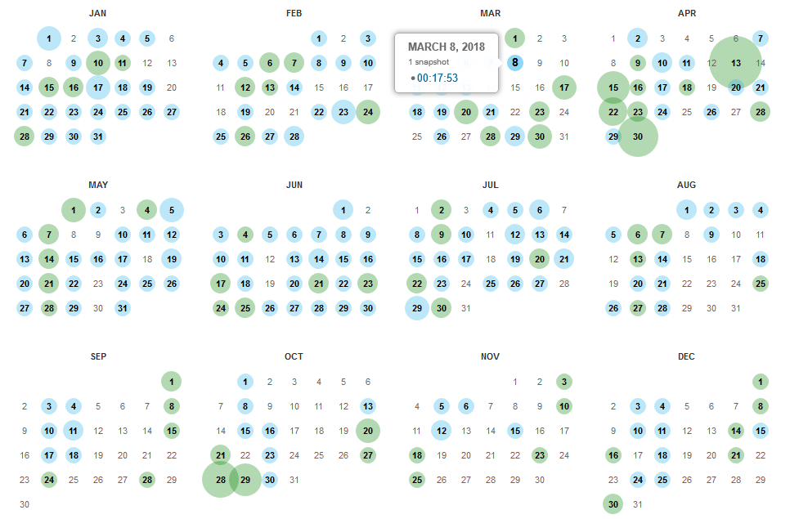

1. Analisis menggunakan Robtex

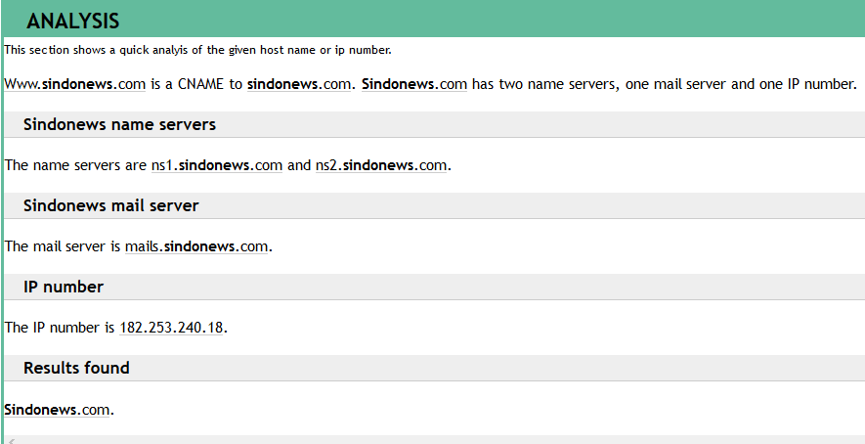

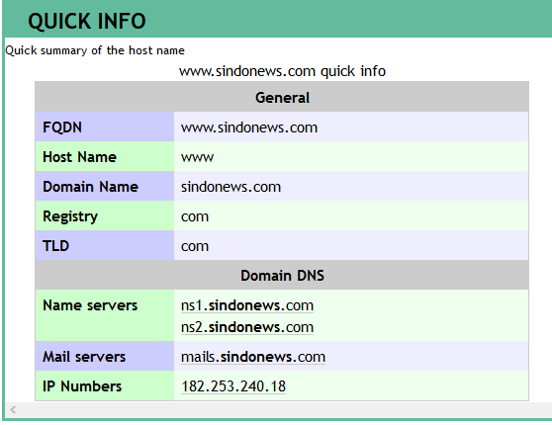

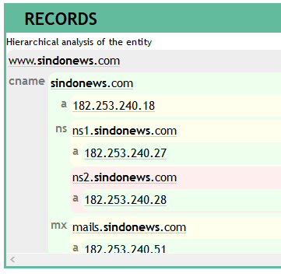

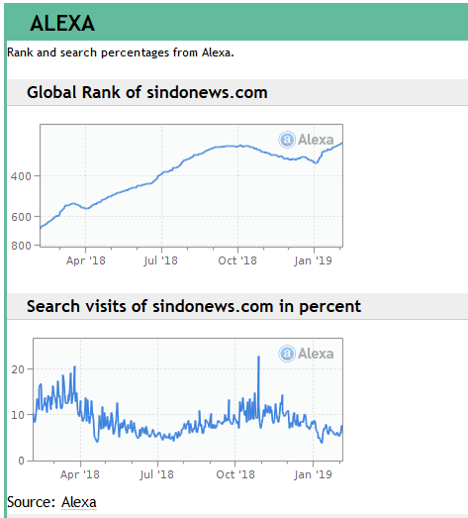

[www.kemenpora.go.id](http://www.kemenpora.go.id)

1. Analisis menggunakan Netcraf

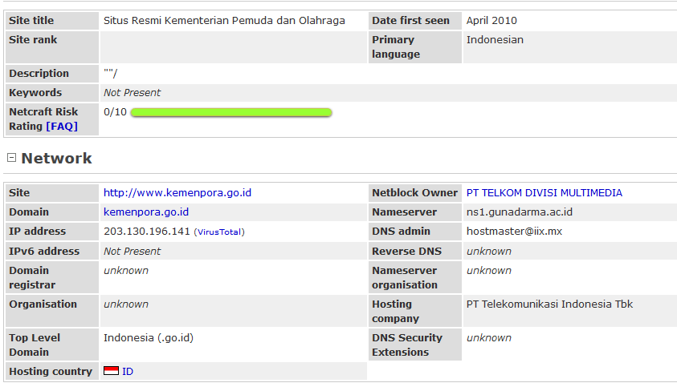

1. Analisis menggunakan Whois

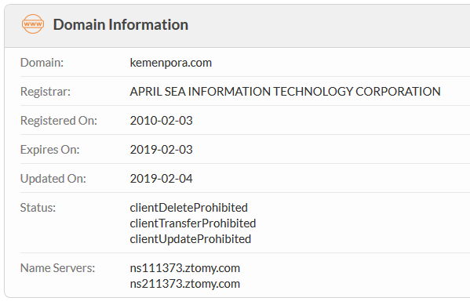

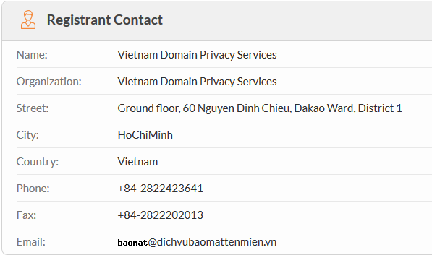

**Raw Whois Data**

Domain Name: kemenpora.com

Registry Domain ID: 1584209628_DOMAIN_COM-VRSN

Registrar WHOIS Server: whois.maprilis.com.vn

Registrar URL: www.maprilis.com.vn

Updated Date: 2018-12-14T00:53:02Z

Creation Date: 2010-02-03T21:08:32Z

Registrar Registration Expiration Date: 2019-02-03T21:08:32Z

Registrar: April Sea Information Technology Corporation

Registrar IANA ID: 1475

Registrar Abuse Contact Email: email@maprilis.net

Registrar Abuse Contact Phone: +84.2838688194

Reseller:

Domain Status: clientDeleteProhibited

Domain Status: clientTransferProhibited

Domain Status: clientUpdateProhibited

Registry Registrant ID: asc-8a976797

Registrant Name: Vietnam Domain Privacy Services

Registrant Organization: Vietnam Domain Privacy Services

Registrant Street: Ground floor, 60 Nguyen Dinh Chieu, Dakao Ward, District 1

Registrant City: HoChiMinh

Registrant State/Province:

Registrant Postal Code:

Registrant Country: Vietnam

Registrant Phone: +84-2822423641

Registrant Phone Ext:

Registrant Fax: +84-2822202013

Registrant Fax Ext:

Registrant Email: email@dichvubaomattenmien.vn

Registry Admin ID:

Admin Name: Vietnam Domain Privacy Services

Admin Organization: Vietnam Domain Privacy Services

Admin Street: Ground floor, 60 Nguyen Dinh Chieu, Dakao Ward, District 1

Admin City: HoChiMinh

Admin State/Province:

Admin Postal Code:

Admin Country: Vietnam

Admin Phone: +84-2822423641

Admin Phone Ext:

Admin Fax: +84-2822202013

Admin Fax Ext:

Admin Email: email@dichvubaomattenmien.vn

Registry Tech ID:

Tech Name: Vietnam Domain Privacy Services

Tech Organization: Vietnam Domain Privacy Services

Tech Street: Ground floor, 60 Nguyen Dinh Chieu, Dakao Ward, District 1

Tech City: HoChiMinh

Tech State/Province:

Tech Postal Code:

Tech Country:

Tech Phone: +84-2822423641

Tech Phone Ext:

Tech Fax: +84-2822202013

Tech Fax Ext:

Tech Email: email@dichvubaomattenmien.vn

Name Server: ns111373.ztomy.com

Name Server: ns211373.ztomy.com

DNSSEC: unsigned

1. Analisis menggunakan Web Archive

Update pada tahun 2018

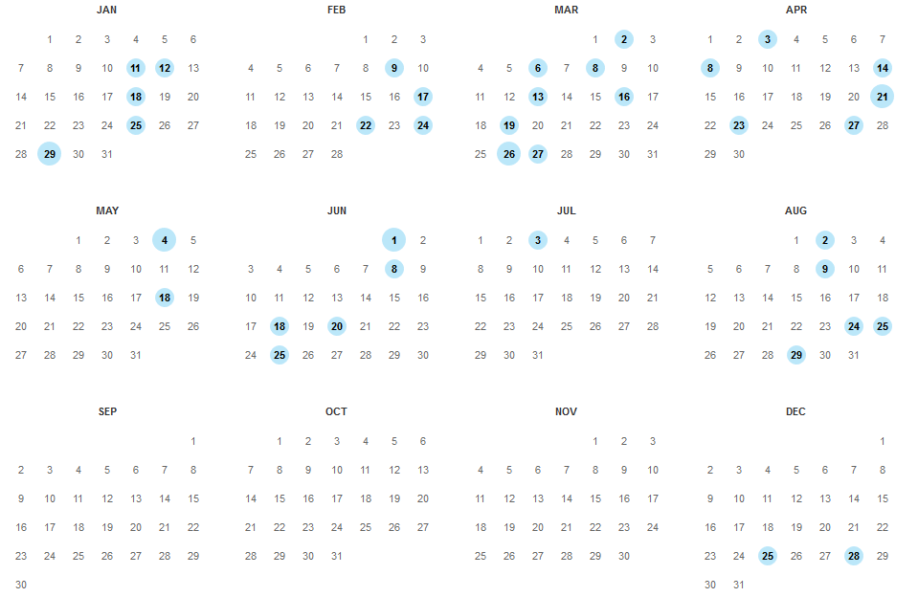

1. Analisis menggunakan Robtex

