Nama : Endi Kumara

NIM : 09011281520098

Kelas : SK7 Pilihan

Mata Kuliah : Manajemen Jaringan

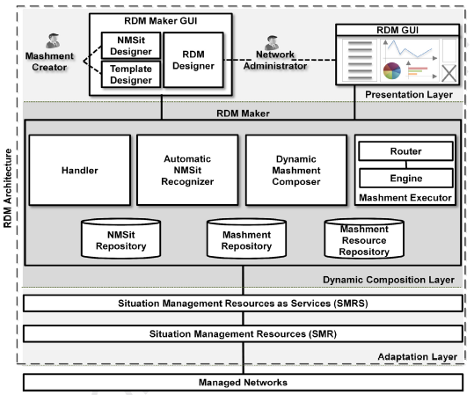**Frameworks**  **Hasil**

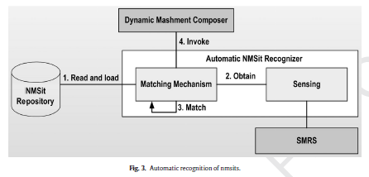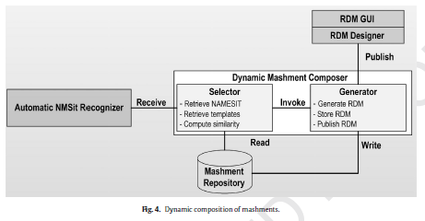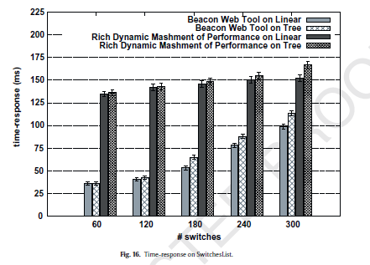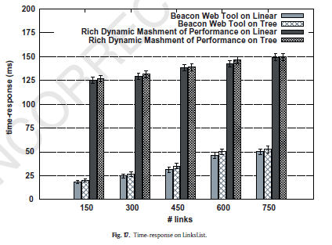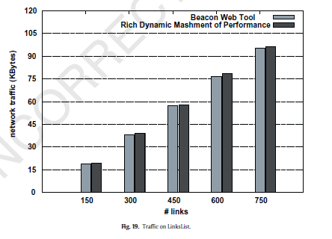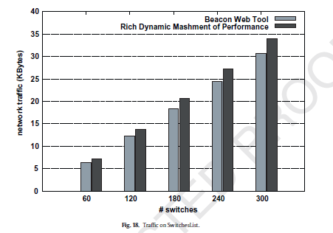

**Rich Dynamic Mashments: An approach for network  
management based on mashups and situation management**