PayLess: A Low Cost Network Monitoring Framework for Software Defined Networks
Shihabur Rahman Chowdhury, Md. Faizul Bari, Reaz Ahmed, and Raouf Boutaba
David R. Cheriton School of Computer Science, University of Waterloo

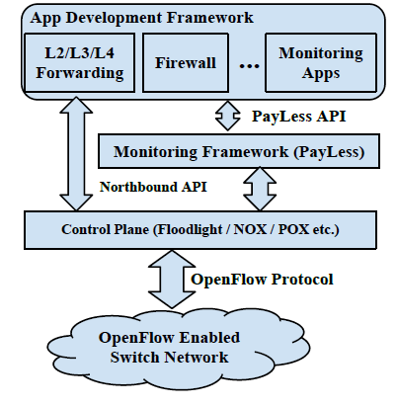 | 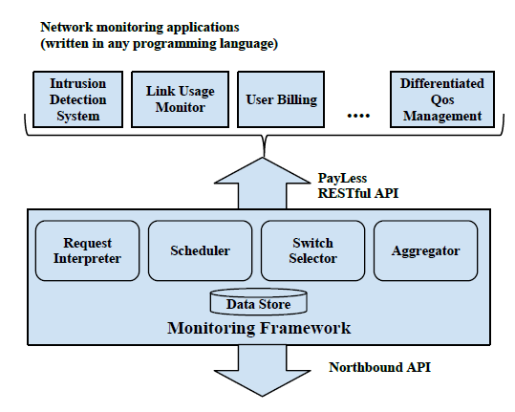 | 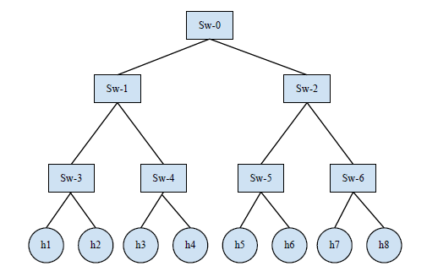
Fig 1. SDN Software Stack | Fig 2. PayLess Network Monitoring Framework | Fig 3. Topology

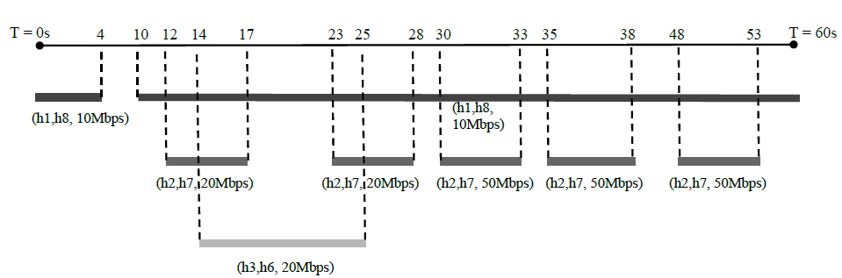

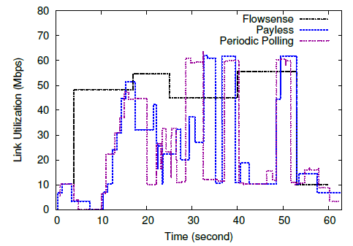 | 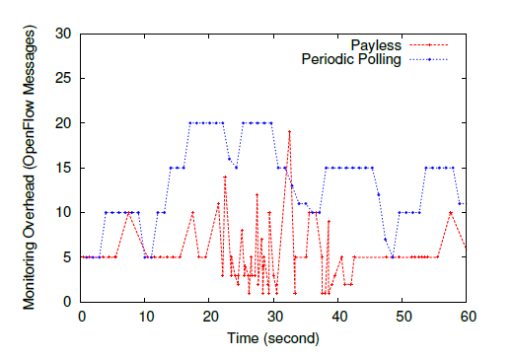 | 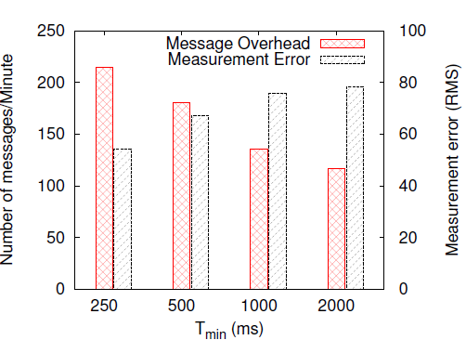
Fig 4. Ultilization Monitoring | Fig 5. Overhead Monitoring | Fig 6. Overhead and Measurement Error

