Monitoring Simple Network Management Protocol (SNMP) with Wireshark

Name : Prinita Ayuningtias
NIM : 09011381520061

Computer Engineering
Faculty Of Computer Scince
Sriwijaya University
2018
Monitoring Simple Network Management Protocol (SNMP) with Wireshark
Monitoring a network is very necessary at this time. Because by monitoring a network we can monitor the status of a network infrastructure, monitor the network in good condition or not and maintain operational stability. Some protocols that can be monitored one of them is the Simple Network Management Protocol (SNMP).
Simple Network Management Protocol (SNMP) is an Internet Standard protocol for collecting and organizing information about managed devices on IP networks and for modifying that information to change device behavior. Devices that typically support SNMP include cable modems, routers, switches, servers, workstations, printers, and more.
SNMP is widely used in network management for network monitoring. SNMP exposes management data in the form of variables on the managed systems organized in a management information base (MIB) which describe the system status and configuration. These variables can then be remotely queried (and, in some circumstances, manipulated) by managing applications.
Three significant versions of SNMP have been developed and deployed. SNMPv1 is the original version of the protocol. More recent versions, SNMPv2c and SNMPv3, feature improvements in performance, flexibility and security. SNMP is a component of the Internet Protocol Suite as defined by the Internet Engineering Task Force (IETF). It consists of a set of standards for network management, including an application layer protocol, a database schema, and a set of data objects [1]

Testing :
Fo get SNMP-based network traffic results and to find out more about SNMP, the test have been conducted by simulating SNMP. Application used to make SNMP topology using GNS3 application.
Figure 1.1 Topology SNMP with GNS3
For the test whether the topology that is connected or not, we must do PING on the Command Prompt by using the IP that is connected to each Router as shown below :
- Test PING Router 1
Figure 1.2 Test PING Router 1
- Test PING Router 2
Figure 1.2 Test PING Router 2
- Test PING Router 3
Figure 1.2 Test PING Router 3
After we test, we will get the SNMP Protocol capture results on the Wireshark application as below:
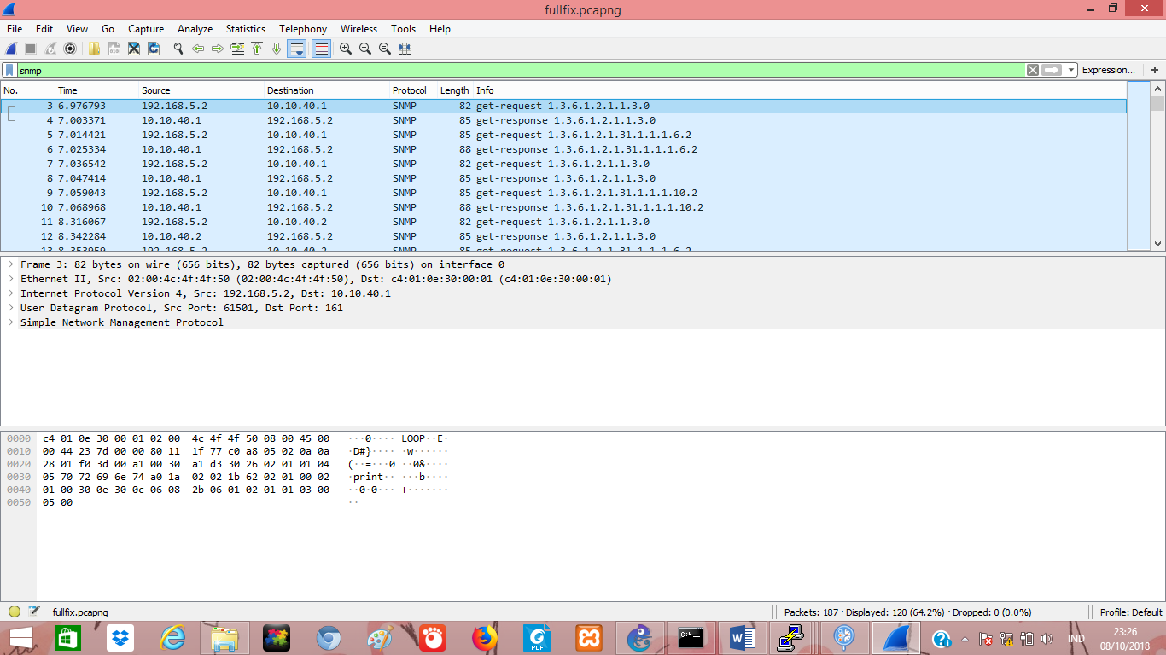
Figure 1.4 Capture SNMP Protocol with Wireshark
Based on capture, the analysis that we can do one of them is that we can see information grouped in Time, Source, Destination, Protocol, etc. Info And to analyze it further then choose the sample with the manager (Source IP Address 192.168.5.2) and agent (IP Address Destination 10.10.40.1) and MAC Address Source (02: 00: 4c: 4f: 4f: 50), MAC Address Destination (c4: 01: 0e30: 00: 01). Below is information about Get Request.

Figure 1.5 Get-Request Information
In this capture we can also find SNMP Get-Request PDU information from the manager agent. In the contents of the message we can know the request-id is 7010 with the bindings numbering 1 item, namely: 1.3.6.1.2.1.1.3.0. After being analyzed when the manager has sent Get-Request 1.3.6.1.2.1.1.3.0. to the agent, the agent will send Get-respone 1.3.6.1.2.1.1.3.0. Get-Response PDU is sent by SNMP agent in reply to a shipment from Get-Request PDU.
Figure 1.6 Sample of agent sent Get-Response to manager
The next analysis is the information from Get-Response, the information obtained is not much different from Get-Request as we can know respone-id, etc. Like the picture below :
Figure 1.7 Get-Response Information

After getting data capture by monitoring using Wireshark, then the data obtained can be visualized using the Orange Data mining application. The data that has been obtained in the format (.csv) can be made as data input in the application and we can visualize it as the example below
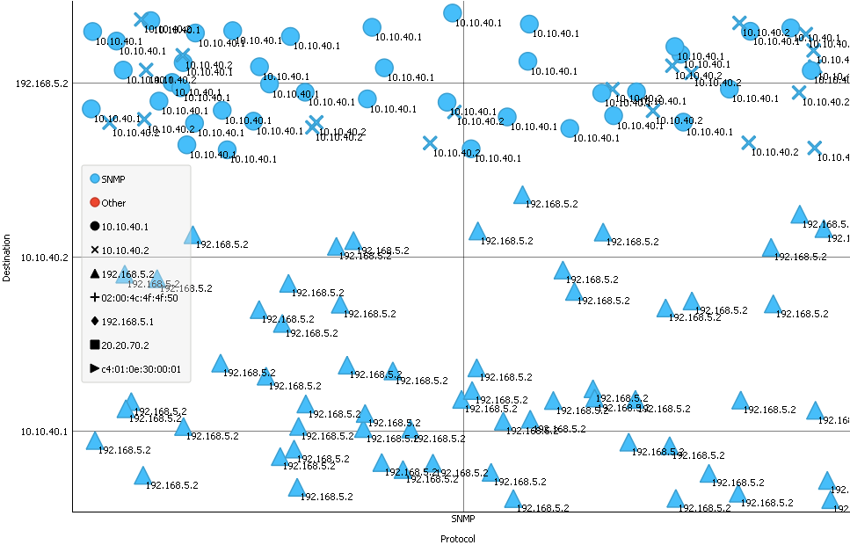
Figure 1.8 Visualization with Orange
In there visualization was described by using Protocol and Destination as (x, y) and Shape which are used to differentiate each Source for easier to understand data and we can differentiate Source that is connected to Destination.

Daftar Pustaka
[1] https://en.wikipedia.org/wiki/Simple_Network_Management_Protocol

