TUGAS 4
KEAMANAN JARINGAN KOMPUTER

Oleh :
Rahmi Khoirani 09011281520104

JURUSAN SISTEM KOMPUTER
FAKULTAS ILMU KOMPUTER
UNIVERSITAS SRIWIJAYA
2018

RECONNAISSANCE NETWORK SECURITY
WWW.PHPMYADMIN.COM

- Foot Printing
- Whois
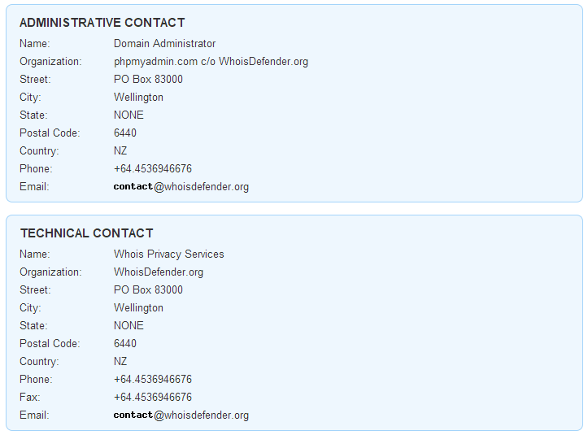
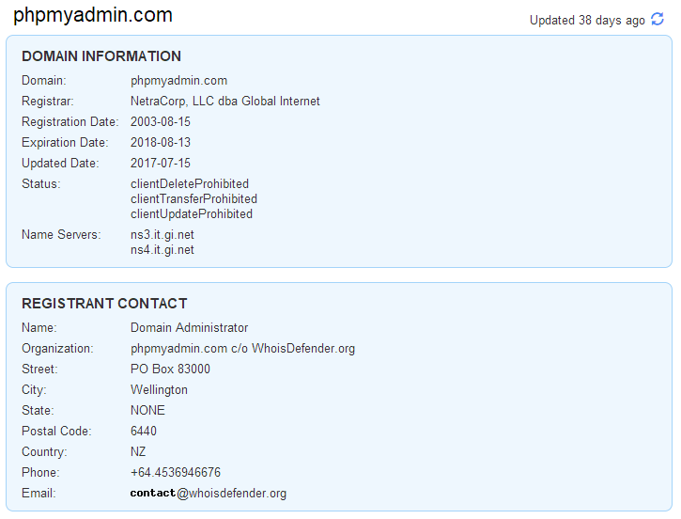
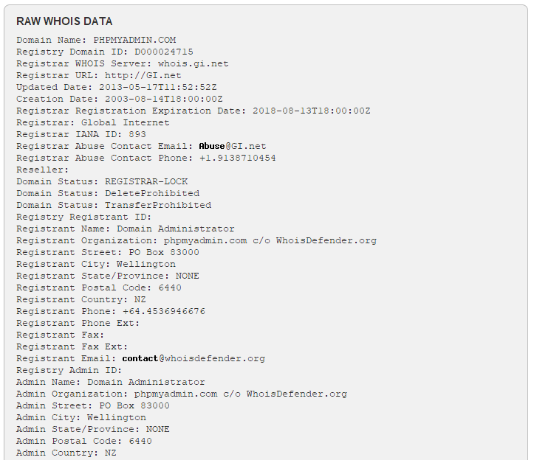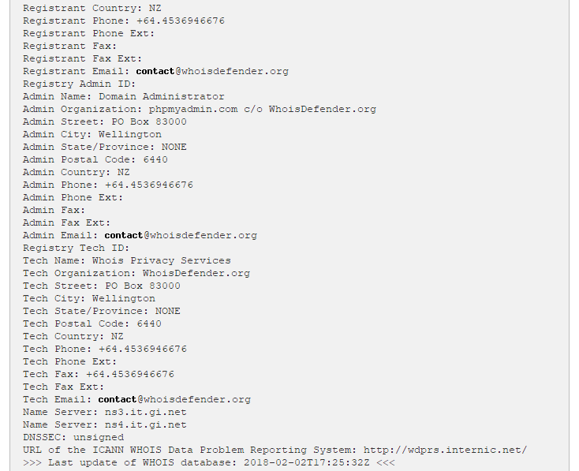
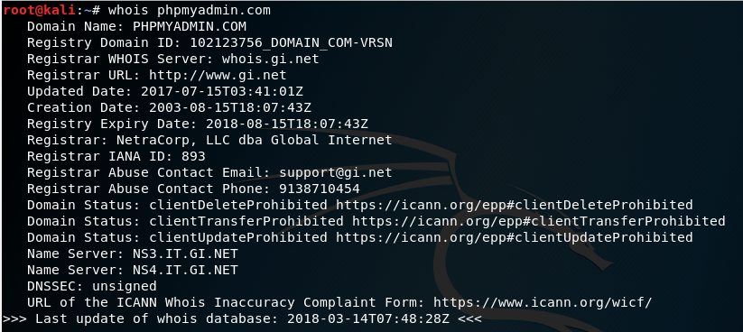

- Whatweb
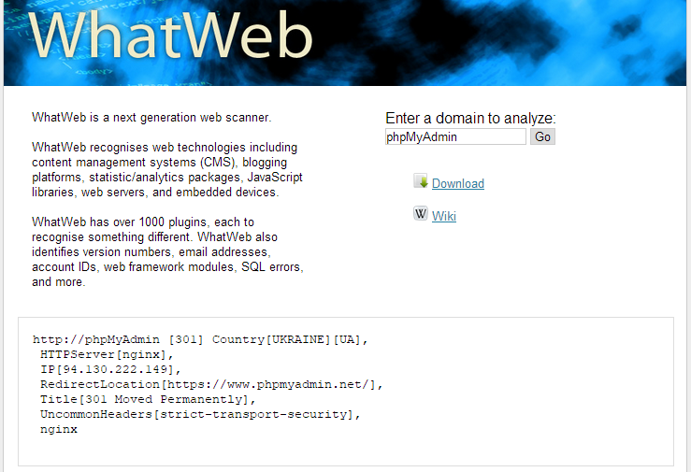
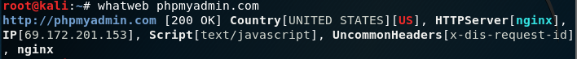

- Necraft
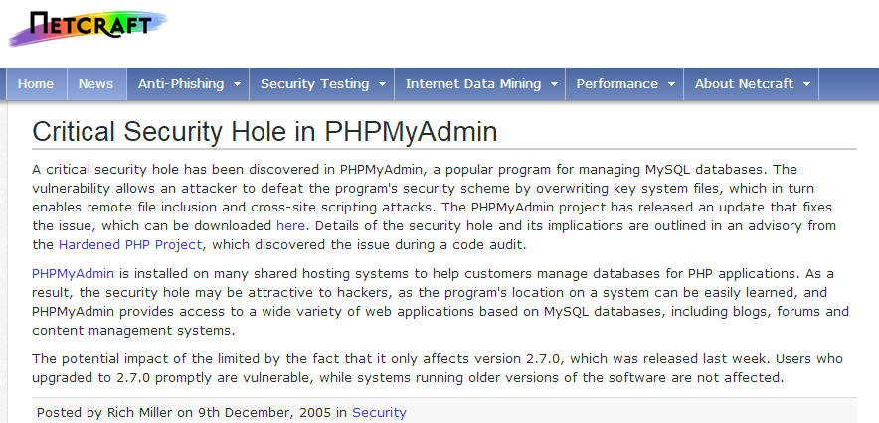

- Reverse Domain
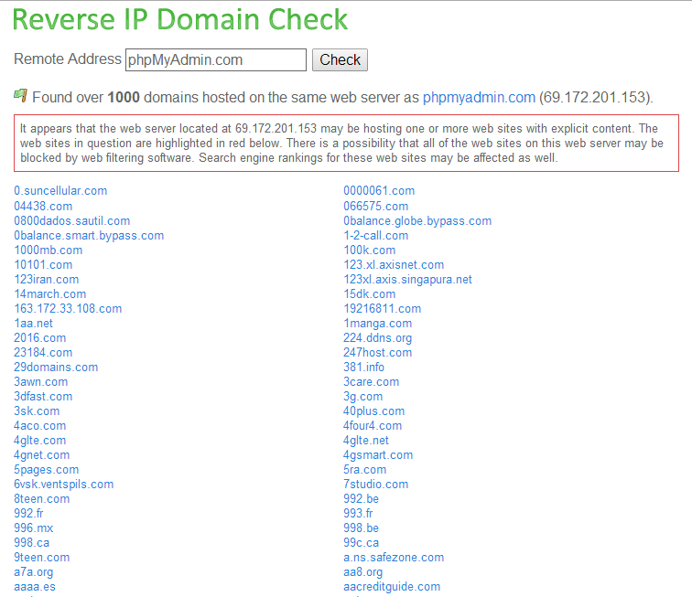
- Scanning Network
- Scanning Network
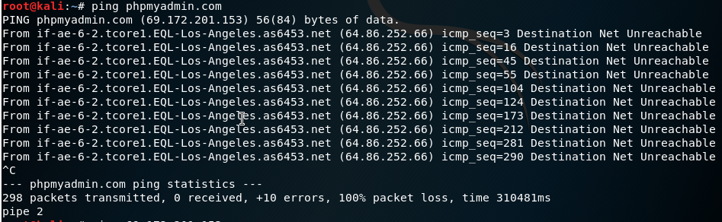
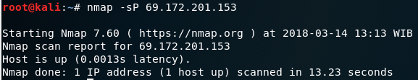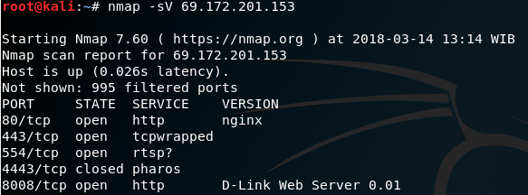

- Scanning Service Tersedia (Part Open)
Phpmyadmin:8008
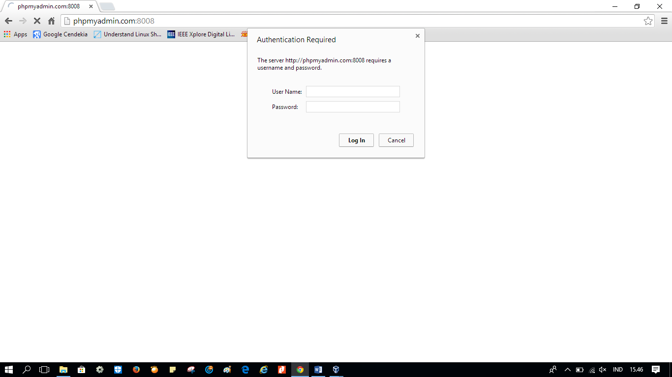

- Scanning Tipe OS
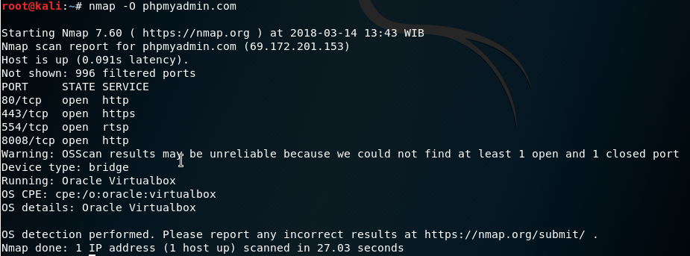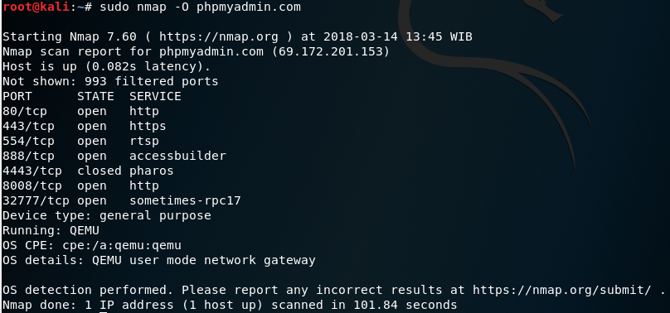

- CVE (Common Vulnerability Exposure)
- CVE Mitre
