Nama : Nadya Rahma Noviyanti
NIM : 09011281520127
Kelas : SK5C

Website : https://learningnetwork.cisco.com/docs/DOC-7558

Level 1
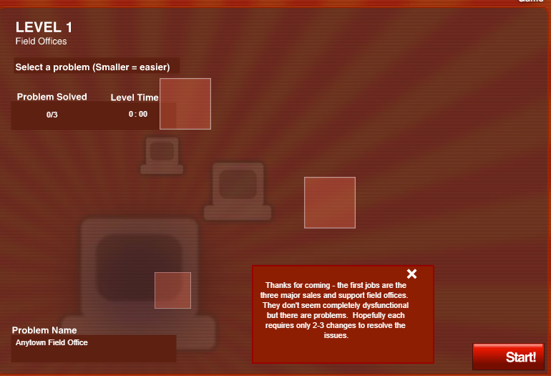

Anytown Field Office

Subnet Mask : 255.255.255.118 diganti dengan 255.255.255.192 karena membutuhkan 4 subnets
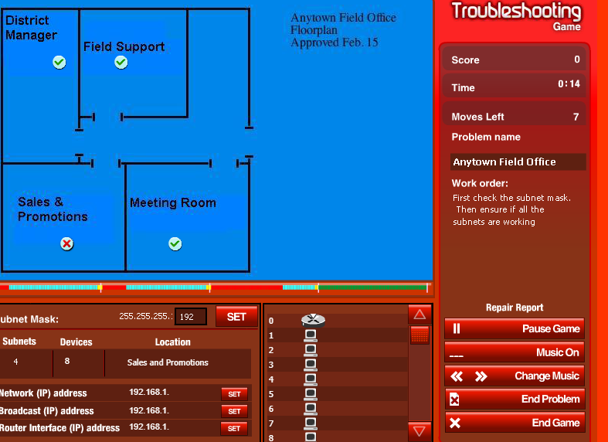

Sales & Promotion

Network Address 192.168.1.192
Broadcast Address 192.168.1.255
Router Interface Adress 192.168.1.254

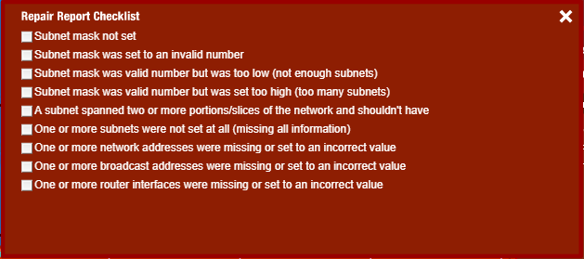
Repair Report Checklist diisi : 2 dan 6
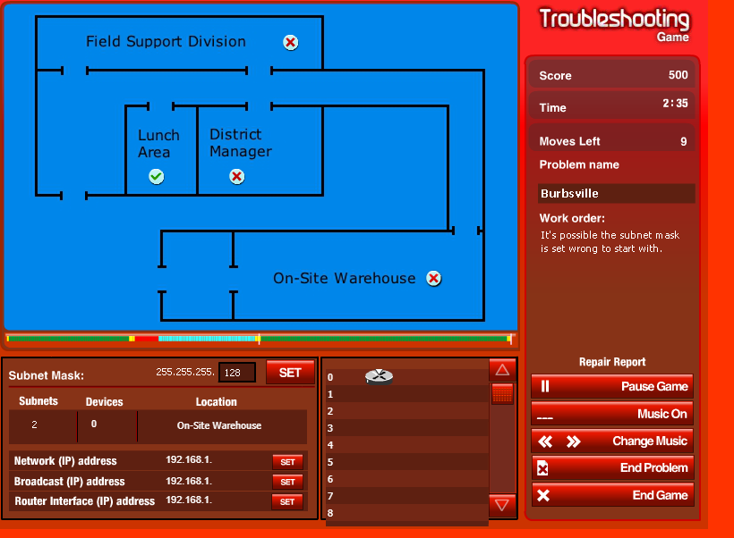
Burbsville
Subnet Mask : 255.255.255.128 diganti 255.255.255.192 karena membutuhkan 4 subnets

District Manager
Broadcast : 192.168.1.191
Router Interface : 192.168.1.190

On-Site Warehouse
Network Address : 192.168.1.192
Broadcast Address : 192.168.1.255
Router Interface Address : 192.168.1.254

Repair Report Checklist : 3,5,6,7,8, dan 9

Metropolis

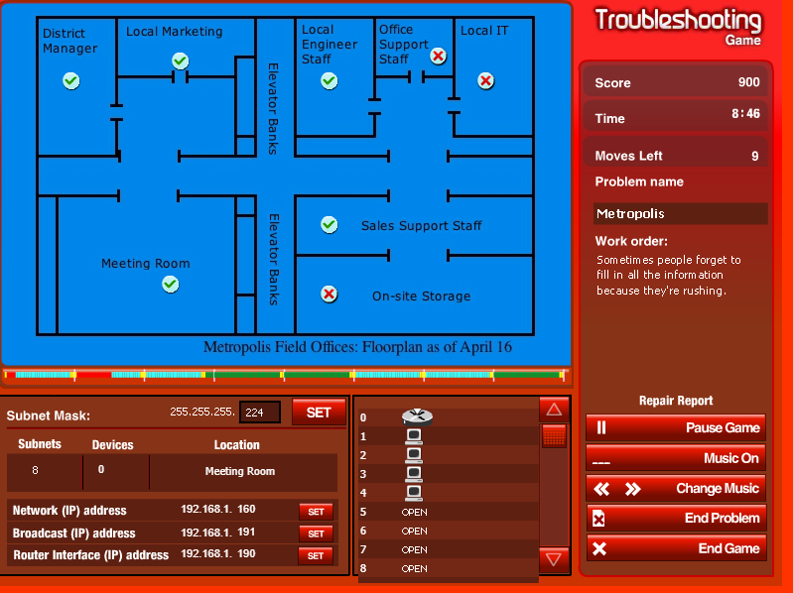
Subnet Mask : 255.255.255.240 diganti dengan 255.255.255.224 karena membutuhkan 8 subnets

Office Support Staff

Network Address : 192.168.1.96

Local IT
Network Address : 192.168.1.128

On-Site Storage
Network Address : 192.168.1.224
Broadcast Address : 192.168.1.255
Router Interface Address : 192.168.1.254

Repair Report Checklist : 4 dan 7

Level 2
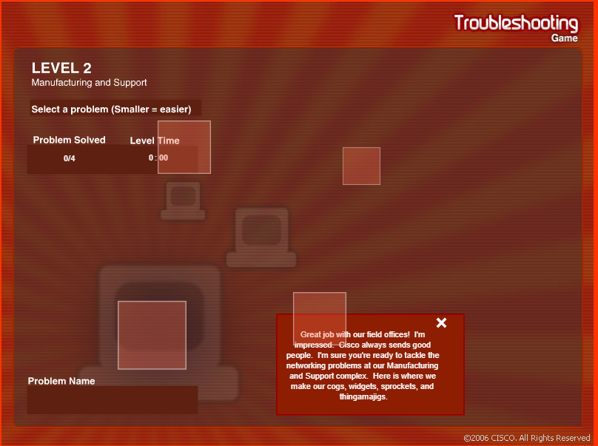

Shipping and Receiving

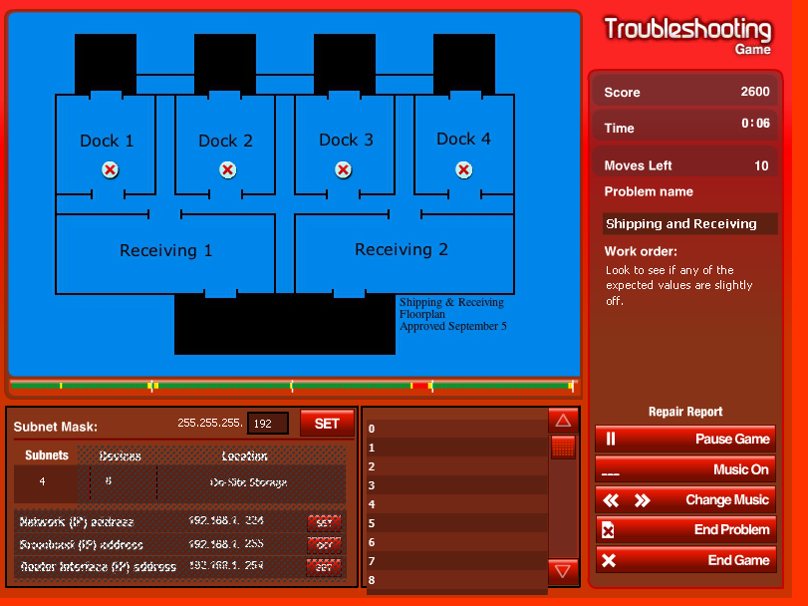

Dock 1
Network Address : 192.168.1.0

Dock 2
Network Address : 192.168.1.64
Router Interface Address : 192.168.126

Dock 3
Network Address : 192.168.1.128

Dock 4
Network Address : 192.168.1.192

Repair Report Checklist : 7 dan 9

Call Center

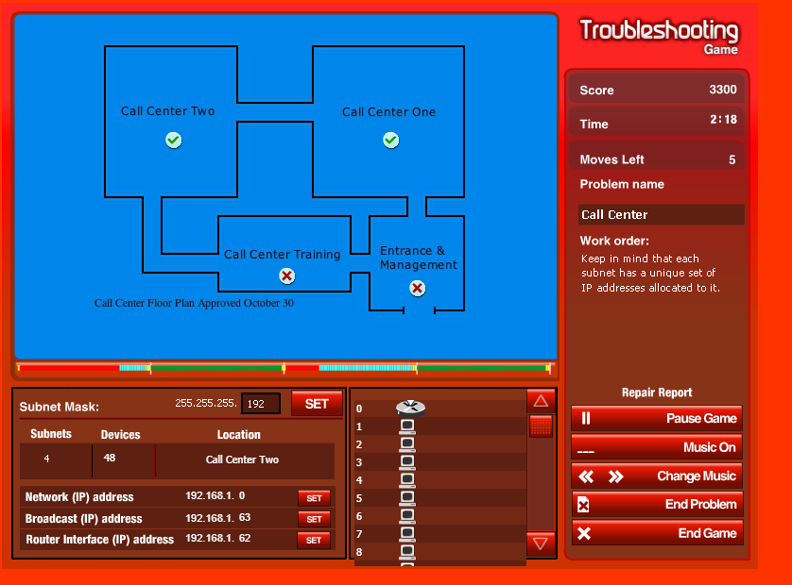

Call Center Training

Network Address : 192.168.1.64
Broadcast Address : 192.168.1.127
Router Interface Address : 192.168.1.126

Entrace and Management

Network Address : 192.168.1.192

Repair Report Checklist : 5,7,8, dan 9

Manufacturing

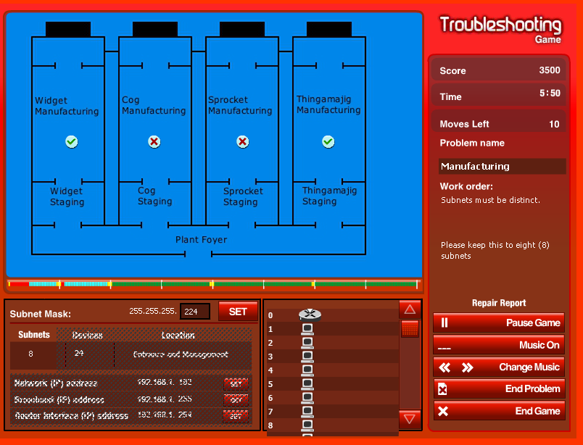
Cog Manufacturing
Network Address : 192.168.1.64
Broadcast Address : 192.168.1.95
Router Interface Address : 192.168.1.94

Sprocket Manufacturing :

Broadcast Address : 192.168.1.159
Router Interface Address : 192.168.1.158

Repair Report Checklist : 5,7,8,dan 9

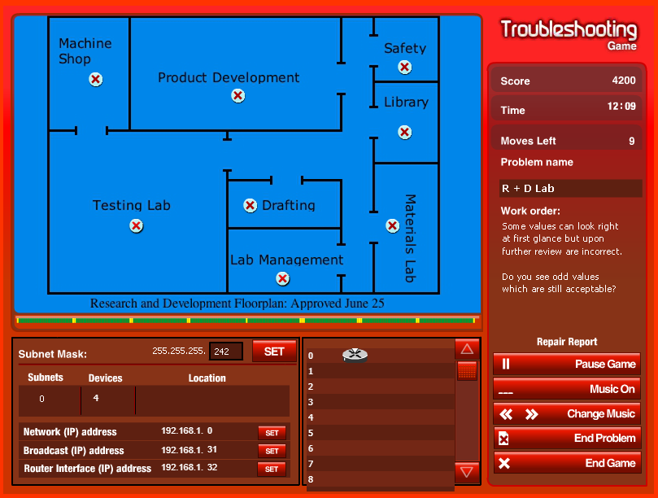
R + D Lab

Subnet Mask : 255.255.255.242 diganti 255.255.255.224 karena membutuhkan 8 subnets

Machine Shop
Router Interface Address 192.168.1.30

Product Development
Router Interface Address 192.168.1.62

Safety
Router Interface Address 192.168.1.94

Library
Network Address 192.168.1.96
Broadcast Address : 192.168.1.127
Router Interface Address : 192.168.1.126

Note : Ketika moves left habis, level completed (?)

