Vicko Bhayyu / 09011181520036 / Jaringan Komputer

Website : https://learningnetwork.cisco.com/docs/DOC-7558

Level 1
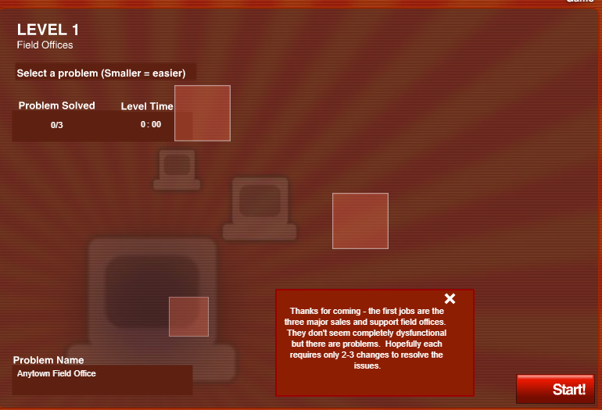

Anytown Field Office

Subnet Mask : 255.255.255.118 diganti dengan 255.255.255.192 karena membutuhkan 4 subnets
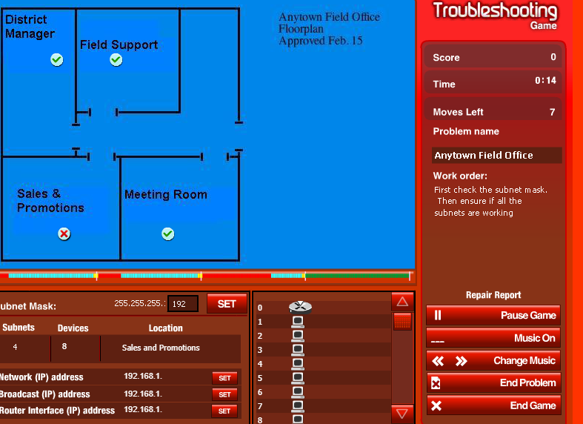

Sales & Promotion

Network Address 192.168.1.192
Broadcast Address 192.168.1.255
Router Interface Adress 192.168.1.254

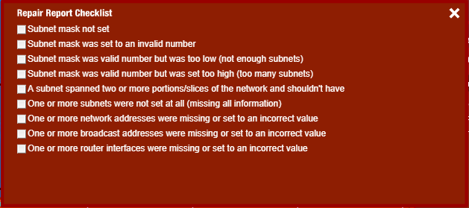
Repair Report Checklist diisi : 2 dan 6
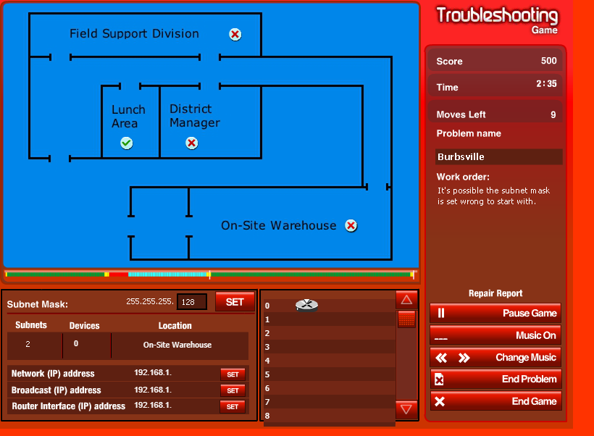
Burbsville
Subnet Mask : 255.255.255.128 diganti 255.255.255.192 karena membutuhkan 4 subnets

District Manager
Broadcast : 192.168.1.191
Router Interface : 192.168.1.190

On-Site Warehouse
Network Address : 192.168.1.192
Broadcast Address : 192.168.1.255
Router Interface Address : 192.168.1.254

Repair Report Checklist : 3,5,6,7,8, dan 9

Metropolis

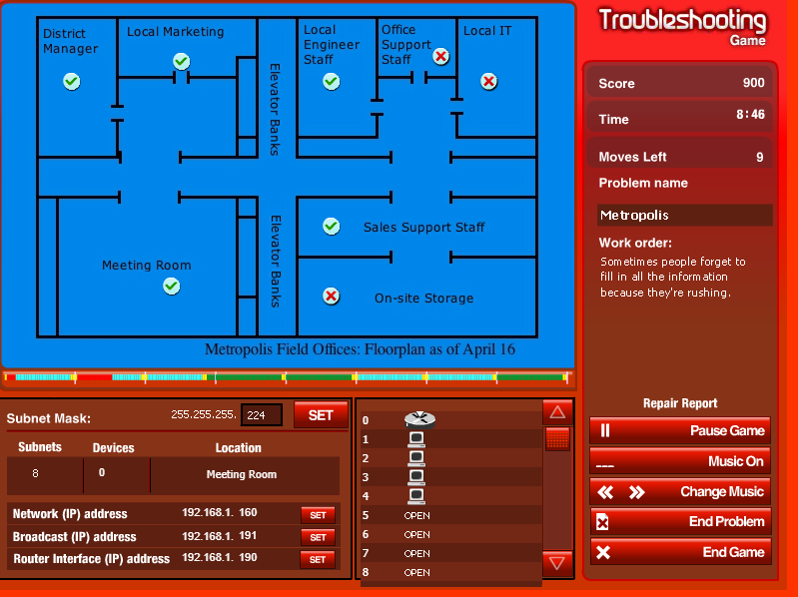
Subnet Mask : 255.255.255.240 diganti dengan 255.255.255.224 karena membutuhkan 8 subnets

Office Support Staff

Network Address : 192.168.1.96

Local IT
Network Address : 192.168.1.128

On-Site Storage
Network Address : 192.168.1.224
Broadcast Address : 192.168.1.255
Router Interface Address : 192.168.1.254

Repair Report Checklist : 4 dan 7

Level 2

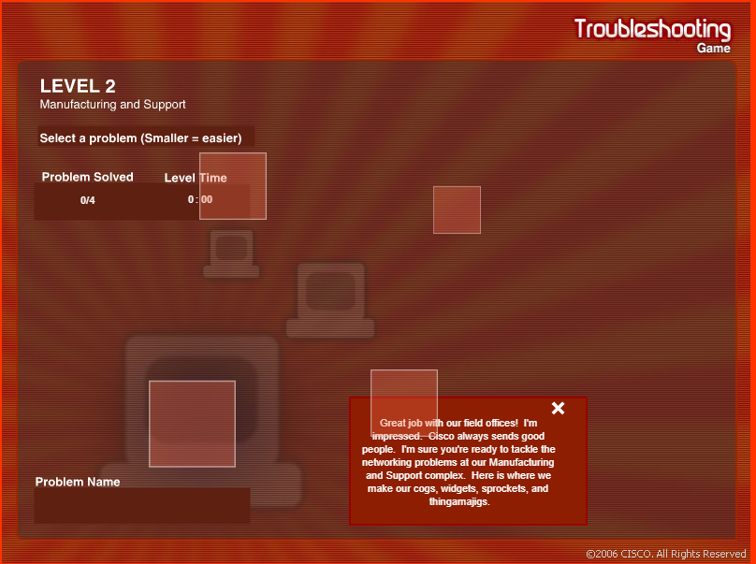

Shipping and Receiving

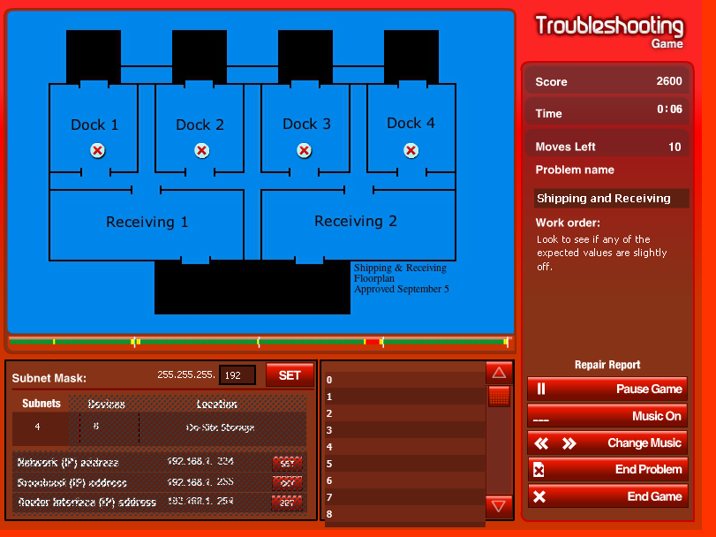

Dock 1
Network Address : 192.168.1.0

Dock 2
Network Address : 192.168.1.64
Router Interface Address : 192.168.126

Dock 3
Network Address : 192.168.1.128

Dock 4
Network Address : 192.168.1.192

Repair Report Checklist : 7 dan 9

Call Center

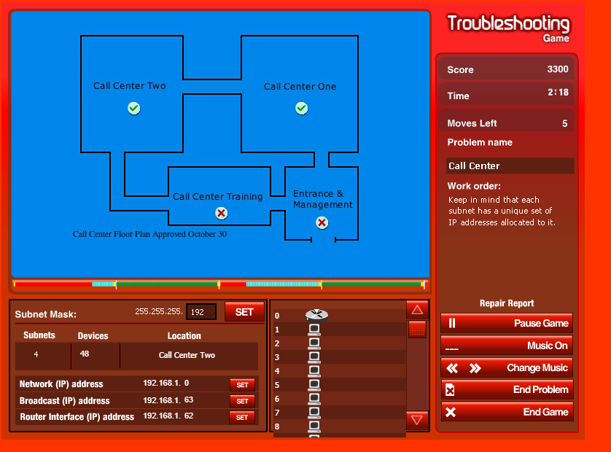

Call Center Training

Network Address : 192.168.1.64
Broadcast Address : 192.168.1.127
Router Interface Address : 192.168.1.126

Entrace and Management

Network Address : 192.168.1.192

Repair Report Checklist : 5,7,8, dan 9

Manufacturing

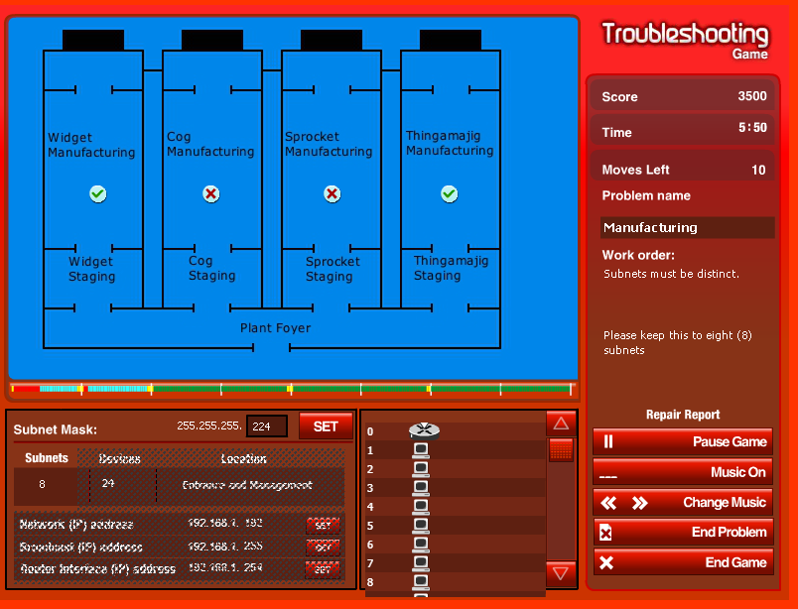
Cog Manufacturing
Network Address : 192.168.1.64
Broadcast Address : 192.168.1.95
Router Interface Address : 192.168.1.94

Sprocket Manufacturing :

Broadcast Address : 192.168.1.159
Router Interface Address : 192.168.1.158

Repair Report Checklist : 5,7,8,dan 9

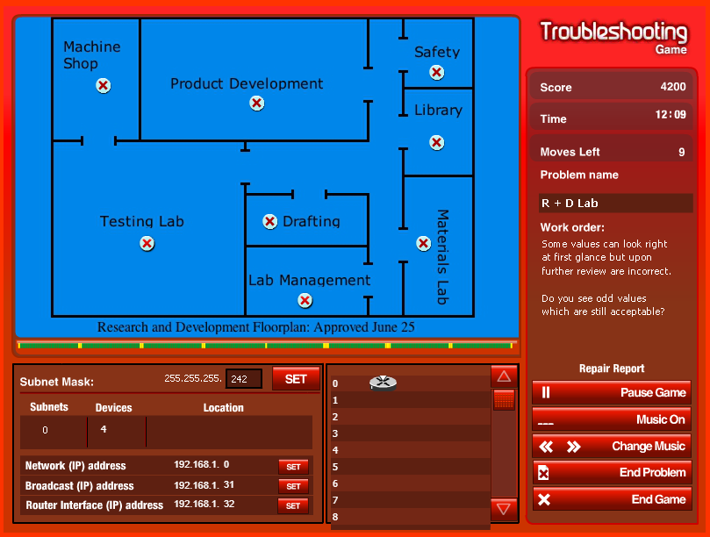
R + D Lab

Subnet Mask : 255.255.255.242 diganti 255.255.255.224 karena membutuhkan 8 subnets

Machine Shop
Router Interface Address 192.168.1.30

Product Development
Router Interface Address 192.168.1.62

Safety
Router Interface Address 192.168.1.94

Library
Network Address 192.168.1.96
Broadcast Address : 192.168.1.127
Router Interface Address : 192.168.1.126

Note : Ketika moves left habis, level completed (?)
Level 3

Distribution

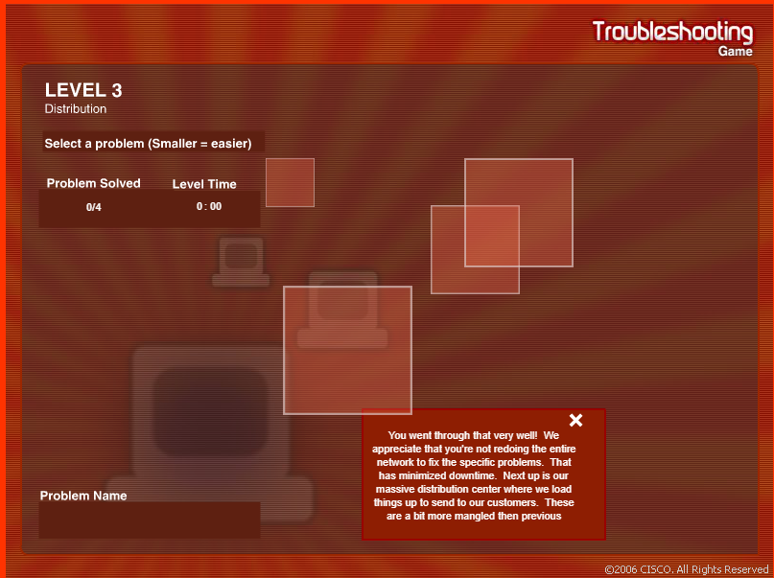

Warehouse

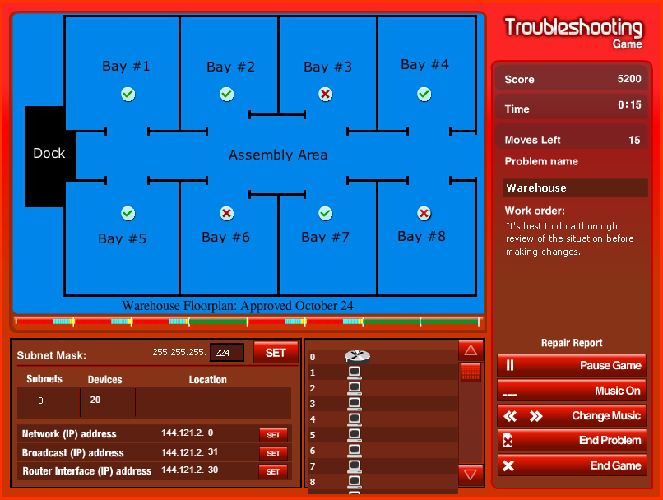

Bay #3

Network Address 192.168.1.96
Broadcast Address : 192.168.1.127
Router Interface Address : 192.168.1.126

Bay #6

Network Address 192.168.1.192
Broadcast Address : 192.168.1.223
Router Interface Address : 192.168.1.222

Bay #8
Network Address 192.168.1.224
Broadcast Address : 192.168.1.255
Router Interface Address : 192.168.1.254
Loading and Shipping

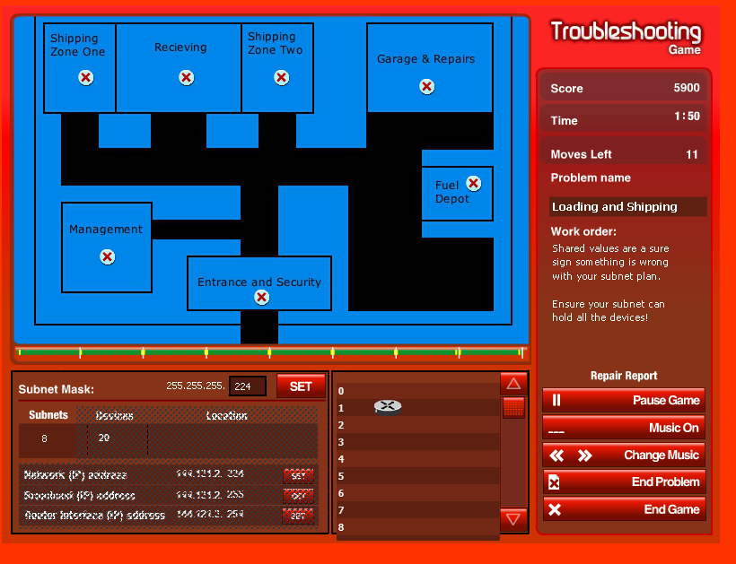

Shipping Zone Two
Router Interface Address 144.121.2.126

Garage & Repairs
Router Interface Address 144.121.2.158

Management
Router Interface Address 144.121.2.190

Receiving
Router Interface Address 144.121.2.94

Entrace and Security
Broadcast address 144.121.2.223
Router Interface address 144.121.2.222

Fuel Depot
Broadcast address 144.121.2.255
Router interface address 144.121.2.254

Shipping Zone One
Router Interface Address 144.121.2.62

Repair Report Checklist : 5,7,8,9

